Emma (Laurer) Shaefer
August 22, 1870 – July 1, 1920

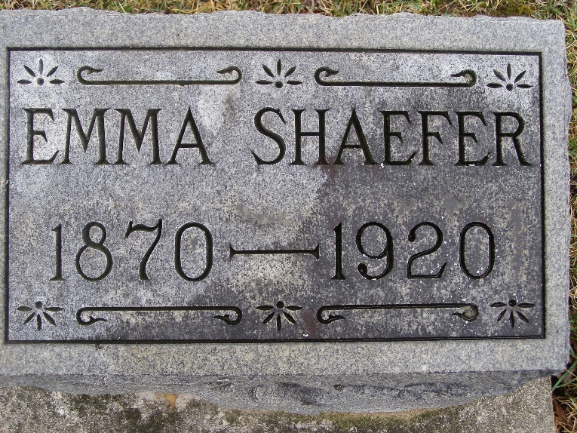
Photo by Shaunda Bedwell Opdycke

Indiana, U.S., Death Certificates, 1899-2017

Name Emma Shaefer
[Emma Laurer]
Gender Female
Race White
Marital Status Married
Age 49y 10m 9d
Birth Date 22 Aug 1870
Birth Place Indiana
Death Date 1 Jul 1920
Death Place Fort Wayne, Ft. Wayne, Indiana, USA
Death Registration Date 1920
Father John Laurer b. Switzerland
Mother --- Chantrei b. Switzerland
Spouse Fred K Shaefer, informant
Burial Berne, Ind. 7/4/1920

