Ruth Mary (Habegger) Seiler
January 13, 1929 – January 30, 2004

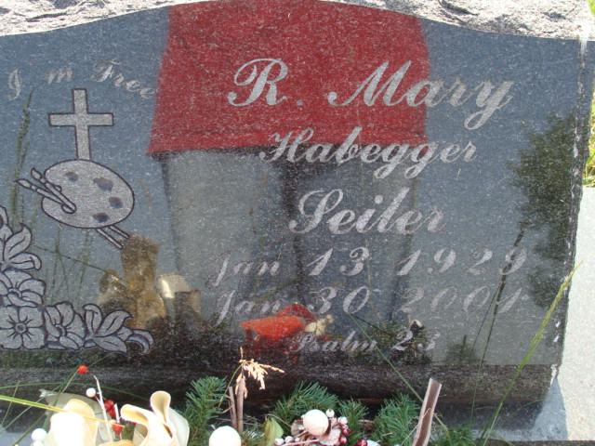
Photo by Alicia Kneuss

R. Mary Campbell Seiler, 72, of Sun City Center, Fla., a native of Berne, Ind., died Wednesday, Jan. 31, 2001, at home.
She had been a collection representative for Comcast and district supervisor for Motherhood Maternity. She was a member of Sun City Center Christian Center and Sun City Center Art Club.
Surviving are a son, Brad Gage of Bryant, Ind.; daughters Judi Shelton of Hamilton, Ohio, and Kathie Bollock of Carbondale, Colo; a sister, Joan Winteregg of Locust Grove, Va.; nine grandchildren and one great-grandchild.
Services are 2 p.m. Sunday at Yager-Kirchhofer Funeral Home, Berne, Ind., with calling from 4 to 8 p.m. Saturday. Burial will be at MRE Cemetery, Berne.
Memorials are to the church Building Fund or LifePath Hospice. Information provided by Yager-Kirchhofer Funeral Home, Berne, 1-219-589-3101.

News-Sentinel, The (Allen County, Indiana)
Friday, February 2, 2001

