Alta Iola (Yaney) Scrogham-Rush
August 2, 1911 – September 9, 1994

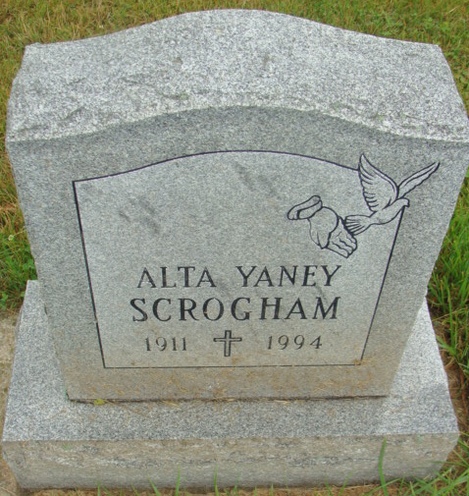
Photo by Alicia Kneuss

Indiana, U.S., Death Certificates, 1899-2017

Name Alta I Rush
[Alta I Yaney]
Gender Female
Race White
Age 83
Marital Status Widowed
Birth Date 2 Aug 1911
Birth Place Adams County, Indiana
Death Date 9 Sep 1994
Death Place Fort Wayne, Allen, Indiana, USA
Death Registration Date 1994
Father Floyd Yaney
Mother Lora Stevens
Informant Larry Crismore; grandson; Berne, Indiana
Burial September 12, 1994; MRE Cemetery; Berne, Indiana
**

Indiana, U.S., Marriages, 1810-2001

Name Alta Iola Yaney
Gender Female
Race White
Age 18
Event Type Marriage Registration (Marriage)
Birth Date 2 Aug 1911
Birth Place Adams, Indiana
Marriage Date 24 Dec 1929
Marriage Place Bluffton, Indiana, United States
Residence Place Bluffton, Indiana
Father Floyd Yaney
Mother Laura Stevens
Spouse Leonard Marshall Scrogham
Page 185
**

Indiana, U.S., Marriage Certificates, 1960-2012

Name Alta I. Scrogham
Gender Female
Age 74
Birth Place Indiana
Marriage Place Ft. Wayne, Allen, Indiana, USA
Marriage Registration Date 1985
Description Adams-Marion
Reference Number 1 Bx1442
Reference Number 2 Tr8467
Spouse Dewalt E Rush
Box Number 2h
Volume Number NA
Certificate Number 85-037317

