Roger L. Scott
December 15, 1937 – March 23, 2014

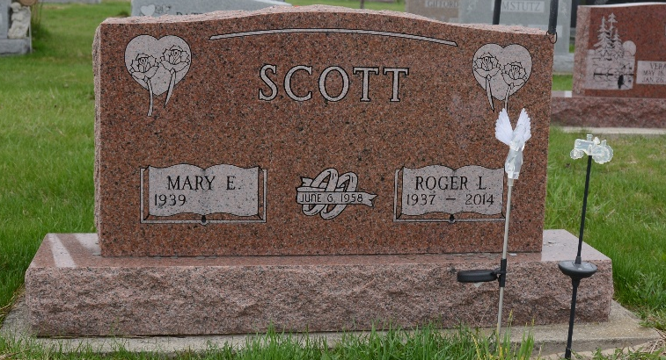
Photo by Deb Curry

Roger Scott, 76 years old of Berne, Indiana, died at his residence on Sunday, March 23, 2014, after a six month illness. He was born on Wednesday, December 15, 1937 in Wells County the son of the late Garland Scott and the late Emma (Tucker) Scott. He married Mary Berry on June 6, 1958 and she survives.
Roger attended Calvary Bible Church in Berne, IN. Rogers family was a very important part of his life. All of his kids and grandkids were very special and important to him. Roger was always busy with new projects. He had a great love for tractors and had always wanted to be a farmer.
Roger was a production worker at General Electric in Decatur, IN until he retired in 1989. He then hauled Amish, mowed lawns, and did construction work after he retired from General Electric.
Surviving are his wife, Mary Scott of Berne, IN; daughter Lisa (Randy) Dudgeon of Berne, IN; daughter Tina (Ed) Crouse of Ft. Wayne, IN ; daughter Rene (Brent) Geary of Fairfax, VA; brother Jim (Karol) Scott of Berne, IN; sister Barbara Zimmerman of Hartford City, IN; ten grandchildren: Jared (Kristina) Dudgeon, Jesse (Dana) Dudgeon, Kyle (Caren) Dudgeon, Whitney (Kyle) Jeffrey, Tristin (Nick) Lichtsinn, Michael (Karlina) Highlen, Brittany (Kyle) Crouse, Ashley Crouse, Ryan Geary, Finn Geary, and 11 great-grandchildren: Lauren, Austin, Ayla, Lillyanna, Jensen, Andersen, Makenzie, Emeryk, Brady, Grayson, Avery.
Funeral services will be held at 10:00 a.m. Friday, March 28, 2014 in the Calvary Bible Church in Berne, IN with Pastor Bill Mohler officiating. Interment will follow in M.R.E Cemetery, Berne.
Friends will be received from 4-8 p.m. Thursday, March 27, 2014 in the Yager-Kirchoffer Funeral Home Berne, IN and one hour prior to services Friday at the church. Preferred memorials to Family Life Care &/or Cancer Services of N.E. Indiana

Zwick & Jahn Funeral Home, Adams County, Indiana

