James "Jim" Edward Scott
October 27, 1944 — December 8, 2021

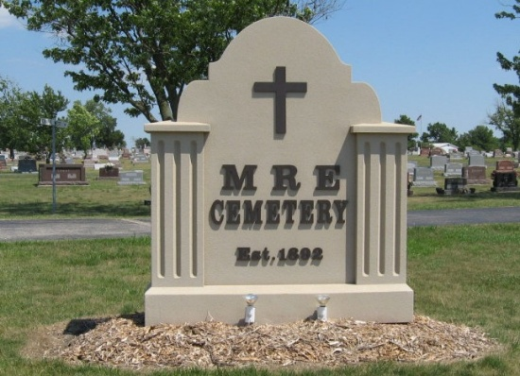
Photo by Tombstoner & Family

James “Jim” Edward Scott, 77, of Berne, Indiana passed away Wednesday, December 8, 2021 at Lutheran Hospital in Fort Wayne, Indiana. He was born on October 27, 1944, in Berne, Indiana to the late Garland S. Scott and the late Emma (Tucker) Scott. Jim was united in marriage to Karol Kirkwood on October 4, 1970, at First United Methodist Church in Petroleum, Indiana.
He served in the National Guard for 6 years. Jim was a member of First Missionary Church in Berne where he served as an usher for many years. Jim worked at General Electric in Decatur and then transferred to Fort Wayne following the closing of the Decatur plant. He retired after 38 years of service.
Jim loved to talk and watch T.V.! He enjoyed his fellowship with his church family along with his friends at McDonalds and Berne Dining.
Survivors include his wife, Karol Scott of Berne, Indiana; son, Mark (Kim) Scott of Berne, Indiana; daughter, Joyce Scott of Berne, Indiana; sister-in-law, Mary Scott of Berne, Indiana; four grandchildren; Cassandra (Zac) Edger, Madilyn Scott, Hannah Scott and Jack Scott; and one great-grandchild, Emery Edger
Jim was preceded in death by sister and brother-in-law, Barbara & Herman Zimmerman; and a brother, Roger Scott.
A funeral service will be held at 10:00 a.m. Monday, December 13, 2021, at First Missionary Church in Berne with Pastor Rick Schwartz officiating. Burial will follow at the M.R.E. Cemetery. For those unable to attend, the service will be livestreamed through the church at www.fmcberne.com. Family and friends will be received from 12 noon – 4:00 p.m. Sunday, December 12, 2021, at the Zwick & Jahn Funeral Home, Yager-Kirchhofer Chapel in Berne, Indiana and one hour prior to services on Monday at the church.
Preferred memorials can be given to First Missionary Church Youth Fund or ACCF- Cancer Fund.

Zwick & Jahn Funeral Home, Adams County, Indiana
December 10, 2021

