Magdalena (Gerber) Schwarz
October 15, 1838 – March 14, 1917

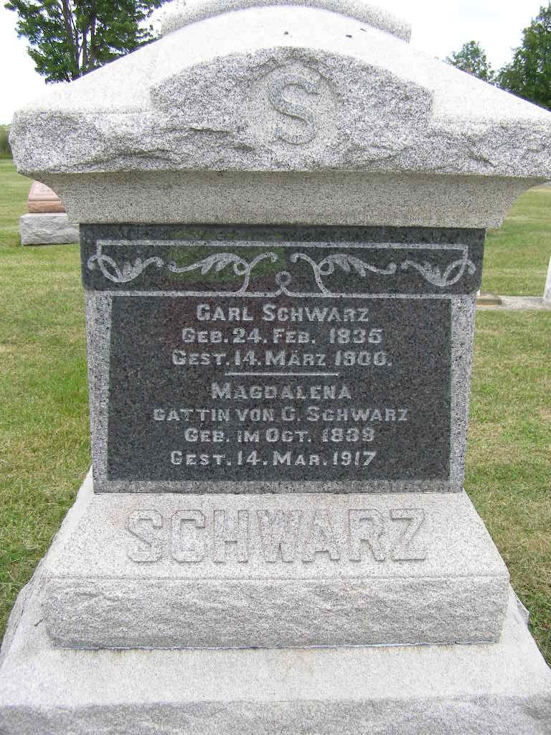
Photo by Shaunda Bedwell Opdycke

Indiana, U.S., Death Certificates, 1899-2017

Name Magdalena Schwartz
Gender Female
Race White
Age 78y 5m
Birth Date 15 Oct 1838
Birth Place Switzerland
Death Date 14 Mar 1917
Death Place Berne, Adams, Indiana, USA
Death Registration Date 1917
Father Christian Gerber b. Switzerland
Mother unknown b. Switzerland
Informant Robert Schwartz
Burial M.R.E. 3-17-1917
**

Magdalina Gerber from tree Zopfi Family Tree

Birth 15 Oct 1838 Switzerland
Marriage 24 Dec 1864 Allen, Indiana, USA
Residence 1880 Adams, Indiana, USA
Death 14 Mar 1917 Berne, Adams, Indiana, USA
Father Christian Gerber (1802-1885)
Mother Magdalena Rohrbach (Died 1843)
Spouse Charles Schwartz (1835-1900)
798 People 7 Records 8 Sources

