Frederick Schwarz
September 11, 1868 – November 22, 1940

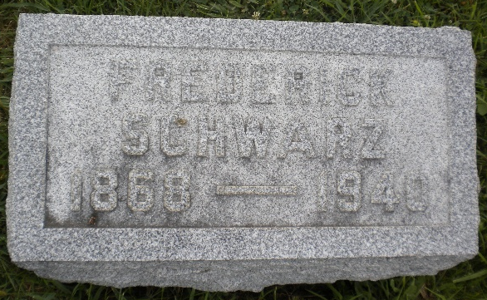
Photo by DSON1492

Indiana, U.S., Death Certificates, 1899-2017

Name Fred Schwartz
Gender Male
Race White
Marital Status Single
Age 72y 2m 11d
Birth Date 11 Sep 1868
Birth Place Berne, Indiana
Death Date 22 Nov 1940
Death Place Fort Wayne, Allen, Indiana, USA
Death Registration Date 1940
Father Carl Schwartz b. Switzerland
Mother Magdelene Gerber b. Switzerland
Informant Mrs. Bertha Moeschberger
Burial 11/24/1940 M.R.E. Cemetery
**

Fredrick Schwartz from tree Maley Family Tree

Birth 11 Sep 1868 Berne, Adams, Indiana, USA
Residence 1880 Adams, Indiana, USA
Death 22 Nov 1940 Fort Wayne, Allen, Indiana, USA
Father Carl Charles Schwartz (1835-1900)
Mother Magdalina Gerber (1838-1917)
19753 People 2 Records 2 Sources

