David C. Schwarz
March 29, 1872 – August 14, 1907

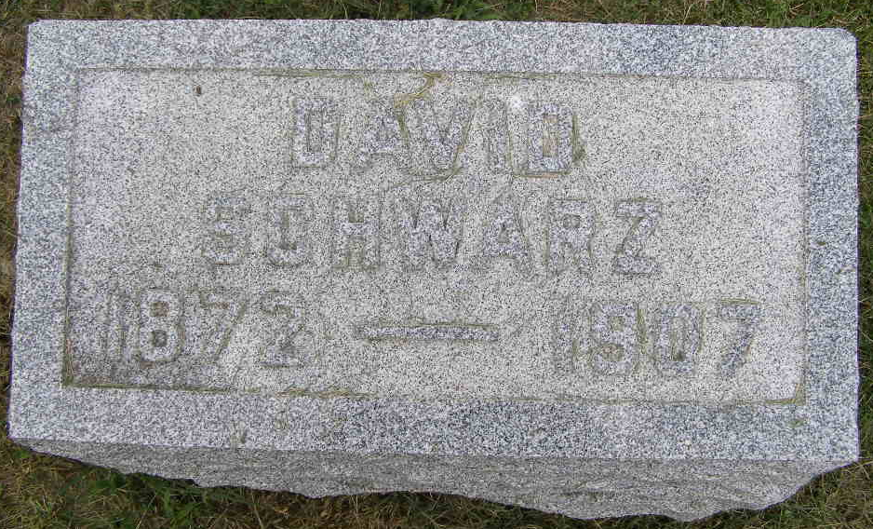
Photo by Shaunda Bedwell Opdycke

Indiana, U.S., Death Certificates, 1899-2017

Name David C Swartz
Gender Male
Race White
Marital Status Single
Age 35
Birth Date 29 Mar 1872
Birth Place Berne, Indiana
Death Date 14 Aug 1907
Death Place Monroe, Adams, Indiana, USA
Death Registration Date 1907
Father Carl Swartz
Mother Madgelene Gerber Swartz, informant
Burial M.R.E. Cemetery 8/16/1907

