Clara Schwarz
April 27, 1873 – November 17, 1875

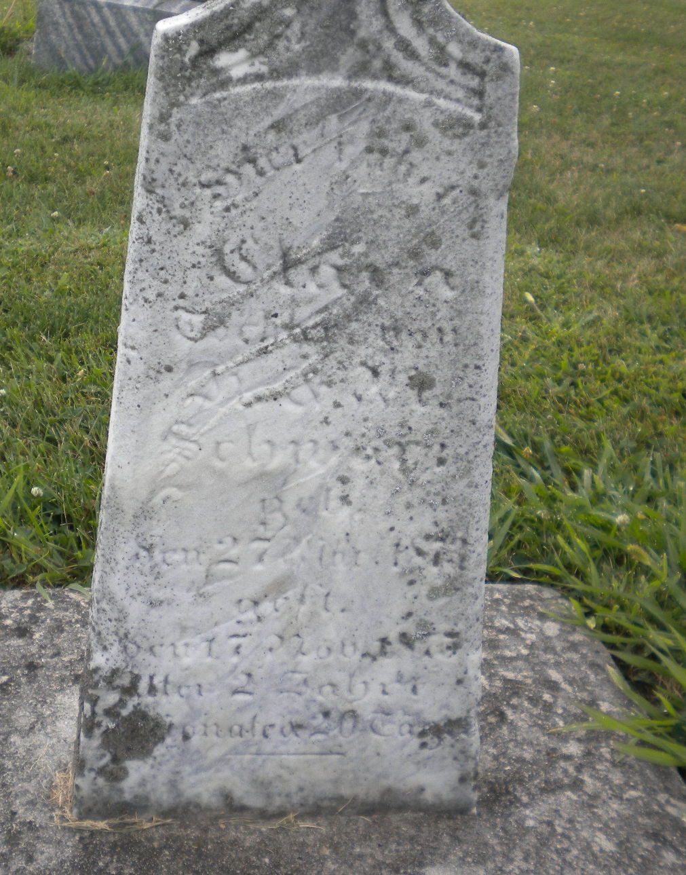
Photo by DSON1492

No further information found at this time.

