Carl Schwarz
February 24, 1835 – March 14, 1900

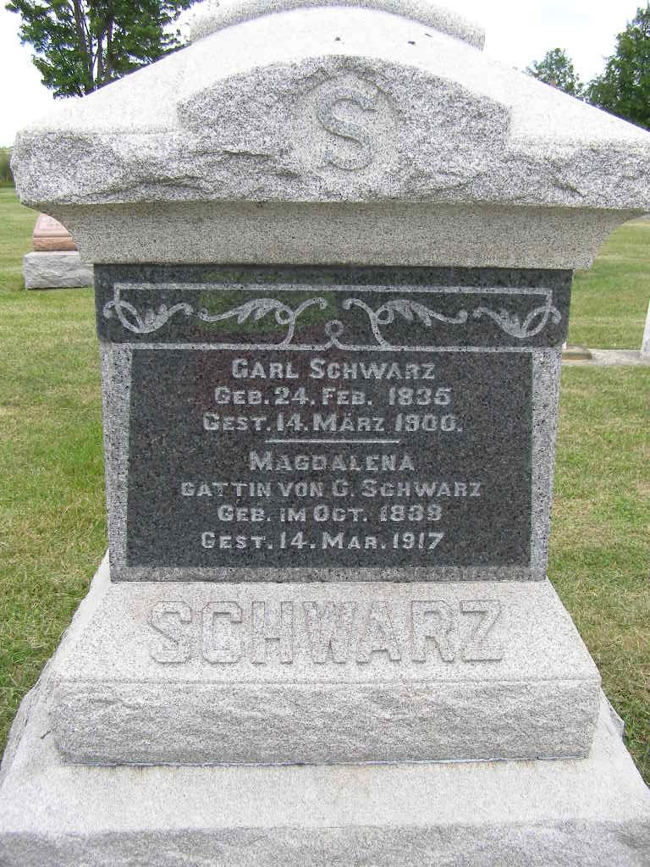
Photos by Shaunda Bedwell Opdycke

Indiana, U.S., WPA Death Index, 1882-1920

Name Karl Schwars
Date Mar 14, 1900
Location Adams County
Gender Male
Race White
Source location County Health Office, Decatur
Source notes The source of this record is the book H-20 on page 20 within the series produced by the Indiana Works Progress Administration.
**

Indiana, U.S., Marriages, 1810-2001

Name Charles Schwartz
Gender Male
Event Type Marriage Registration (Marriage)
Marriage Date 24 Dec 1864
Marriage Place Indiana, United States
Spouse Magdaline Garver
Page 432; FHL Film Number 002321470
**

Charles Schwartz from tree Meyer Family Tree 2016-2

Birth 24 Feb 1835 Bern, Switzerland
Marriage 29 Dec 1864
Residence 1880 Adams, Indiana, USA
Death 14 Mar 1900 Berne, Adams, Indiana, USA
Father Ulrich Schwartz (Died 1853)
Mother Anna Elisabeth liechty Stucki (Died 1854)
Spouse Magdalena Gerber (1838-1917)
11736 People 3 Records 5 Sources

