Turner Douglas Schwartz
September 6, 1989 – December 14, 2021

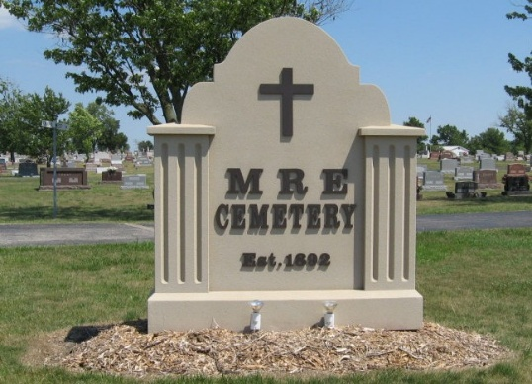
Photo by Tombstoner & Family

Turner Douglas Schwartz, 32, of Berne, Indiana, went to be with his Lord Jesus on Tuesday, December 14, 2021, at 2:55 p.m. at Lutheran Hospital as a result of injuries sustained when a tree fell on his truck in Saturday’s wind storm. Turner’s parents are Douglas and Linda (Dynes) Schwartz.
Turner enjoyed shooting sports, motorcycles, his cars and trucks, and playing games with family and friends. He enjoyed being with people and sharing in their lives.
He is survived by his parents; sister, Kelsey (James) Sallee; uncle and aunt, Jeff and Mary Ann (Schwartz) Dynes; and cousins, Nicole and Michael Dynes, all of Berne. Turner was preceded in death by his grandparents, Harry and Romona Schwartz, and Birthel “Gene” and Shirley Dynes.
Calling will be held at First Missionary Church on Saturday, Decem-ber 18, 2021 from 11:00 a.m. to 3:00 p.m. Those who would like to may bring a favorite board game and enjoy a time of fellowship as we celebrate the connection we have through Turner. A graveside service will follow calling hours at MRE Cemetery. A Celebration of Life service will be held at First Missionary Church on Sunday, December 19, 2021 at 1:30 p.m. with Pastor Rick Schwartz officiating.
If you would like to honor Turner’s memory through a gift, memorials may be designated to the family to cover medical expenses or to Honey Lake Mental Health Clinic Scholarship Fund. Due to chronic health issues within the family, masks will be required. If you are not feeling well, we ask that you join us via the livestream of the service at www.fmcberne.com . We appreciate your consideration regarding this.

Zwick & Jahn Funeral Home, Adams County, Indiana

