Thomas Schwartz
September 23, 1940 – September 23, 1940

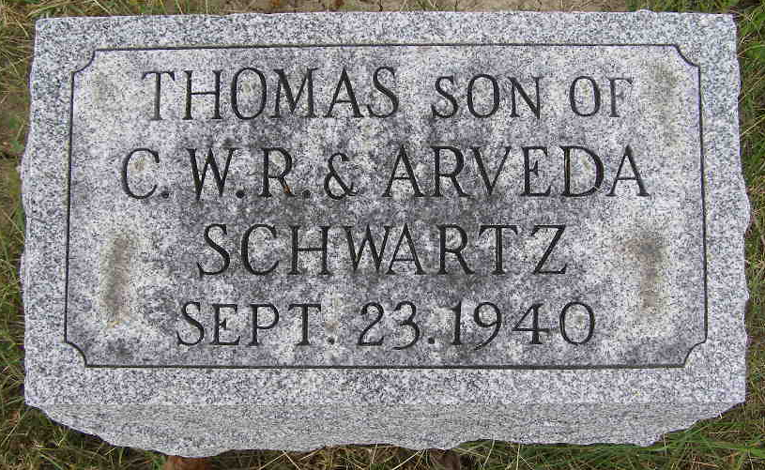
Photo by Shaunda Bedwell Opdycke

Thomas (Tommy) Schwartz from tree Mercer Family Tree/ 12/01/201
Birth 23 Sep 1940
Death 23 Sep 1940
Father Christian WIlliam Robert Schwartz (1888-1951)
Mother Arveda Mayme Rumple (1899-1956)
27132 People 1 Record 3 Sources

