Sylvia Magdalena Schwartz
January 14, 1898 – June 25, 1973

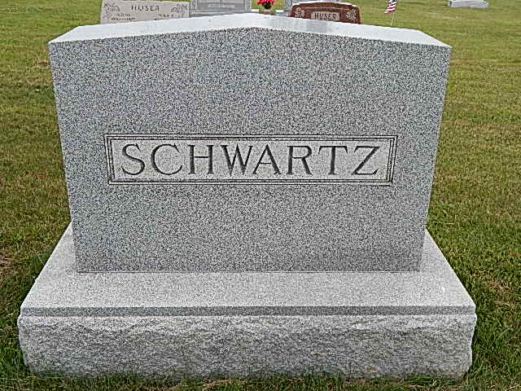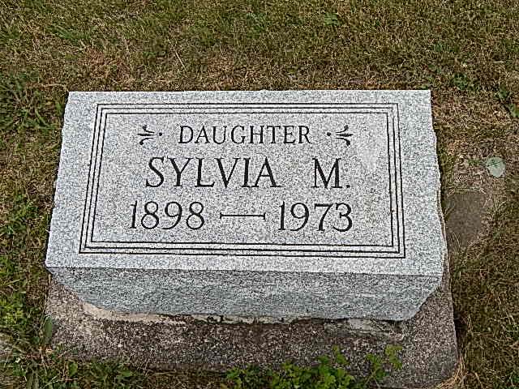
Photos by Alicia Kneuss

Miss Schwartz dies at hospital

Sylvia Magdelena Schwartz, 75, 505 Water St., Berne, died at 1 p.m. Monday at the Adams county memorial hospital after an illness of two days. She had been in failing health for two months.
Her funeral will be Thursday at 10 a.m. at the Cross United Church of Christ, with the Rev. Wilson Bixler officiating; burial will be in the MRE cemetery and visitors may call at the Yager funeral home in Berne after 2 p.m. Wednesday.
Miss Schwartz was born January 14, 1898 in Berne to Robert and Rosina Burke-Schwartz. She was a lifelong resident of the county, a member of the Cross United church, a Sunday school teacher for many years, and was employed as a secretary and practical nurse.
She was a nurse for 23 years with Dr. Harry and Dailey Jones and was a secretary for Gottschalk Supply and the Adams county Farm Bureau office in Monroe. She also was a member of the Dorcas Circle and worked part-time in the Berne public library.
She had two sisters, Mrs. John (Florence) Steiner of Geneva and Mrs. Alfred (Serena) Marhenke of Berne and one brother, Elmer K. Schwartz of Kendallville. Also in the family were two nieces and two nephews.

Decatur Daily Democrat, Adams County, Indiana
Tuesday, June 26, 1973
**

SYLVIA SCHWARTZ, RETIRED NURSE, DIES SUDDENLY
Miss Sylvia Magdalena Schwartz, 75, a lifelong resident of this community, died unexpectedly at 1 p.m. Monday at the Adams County Memorial hospital where she was admitted Sunday evening. She had been in failing health two months but seriously ill only two days. Miss Schwartz resided at 506 West Water street in this city.
She was widely known in the community. She served as secretary and practical nurse for the last Dr. D.D. Jones and Dr. H. O. Jones for 23 years. Later she served as office secretary at Gottschalk Supply Company and Adams County Farm Bureau Co-op at Monroe and after retirement worked part time at the Berne Public Library. Miss Schwartz was a member of the Cross United Church of Christ and taught a Sunday School class for many years. She was a member of the Dorcas Circle, Girls Guild and Women’s Guild of the church.
Miss Schwartz was born in Berne January 14, 1898, the daughter of Robert and Rosina Burke Schwartz.
Surviving are a brother, Elmer K. Schwartz, Kendallville and two sisters, Mrs. John (Florence) Steiner, R.R. 1, Geneva and Mrs. Alfred (Surena) Marbenke, Berne. Two nephews and two nieces survive.
Services will be held at 10 a.m. Thursday at the Cross United Church of Christ, Rev. Wilson Bixler officiating. Burial will be in the M.R.E. cemetery.

Burial on Lot 545 Orig. Platt
Death Date: 8 Jun 1973 (sic) Burial Date: 27 June 1973

Berne (IN) Library Heritage Room
MRE Obits 1973-1984, image #019

