Sidney Leon Schwartz
June 6, 1942 – August 4, 2016

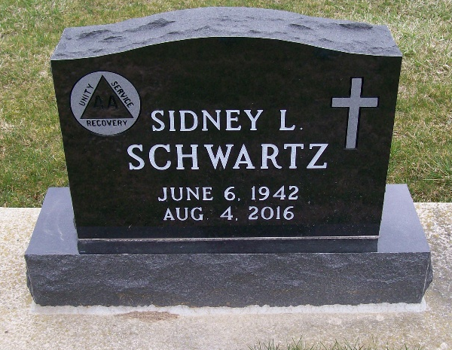
Photos by Scott Shoup

Sidney L. "Sid" Schwartz, 74, of Monroe, IN, passed away on Thursday, August 4, 2016, in the Bluffton Regional Medical Center. He was born on June 6, 1942 in Adams County, IN, the son of the late Harold and Marybelle (Snyder) Schwartz. He was the co owner of Schwartz Precision Collision.
During his lifetime, he was a jockey and was very influential in many lives as an AA facilitator. He started hosting AA meetings in 1978. Sid spent his life helping others and was a great Christian example through his giving spirit. Sid enjoyed spending time with and supporting his grandkids. He also loved hunting and fishing.
He is survived by 2 sons, Doug (Ann) Schwartz of Monroe and Denny (Leann) Schwartz of Decatur; 5 grandchildren, Kayla (Andrew) Priem, Kelsey (Bryce) Sprunger, Madeline, Conner & Makenna Schwartz.
Visitation will be from 2:00 – 8:00 p.m. on Monday, August 8, 2016 at Haggard-Sefton & Hirschy Funeral Home. A Funeral Service will be held at 10:00 a.m. on Tuesday, August 9, 2016 at Haggard-Sefton & Hirschy Funeral Home, with calling 1 hour prior to the service from 9:00 – 10:00 a.m. Officiating will be Pastor Michael Wertenberger and burial will take place in the M.R.E. Cemetery.
Memorials may be made to St. Luke Church Youth.

Haggard-Sefton & Hirschy Funeral Home, Adams County, Indiana

