Ruth E. (Nussbaum) Schwartz
December 22, 1920 - July 4, 2012

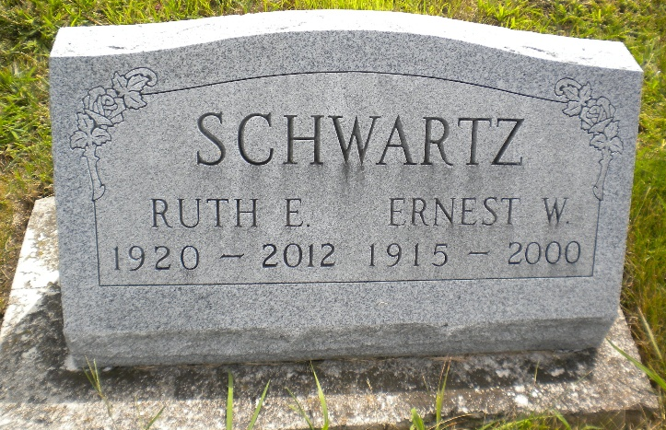
Photo by Alicia Kneuss

Ruth E. Schwartz, 91, Berne, passed away July 4, 2012 at Swiss Village. She was born to Wilbert and Lila (Sprunger) Nussbaum on December 22, 1920 in Adams County. She married Ernest W. Schwartz on October 6, 1940 in Berne.
Ruth was a member of the First Mennonite Church where she sang in the choir and was a member of the Mennonite Choral Society. She enjoyed quilting, sewing, hand crafts, and crocheting.
Survivors include: daughters, Jocelyn (James) Blum of Ft. Wayne, Amy (Ken) Troutman, of Syracuse and a son, Ted (Lana) Schwartz of Berne. Also 6 grandchildren; Jennifer (Bob) Nahrstadt of Atlanta, Ga., Joan (Bill) Doran of Elgin, Il., Julie Olson of Yorktown, In., Jeff (Nena) Troutman of Ossian, In., Jason (Becki) Schwartz , Berne, In., Lendon (Tiffany) Schwartz, Yorktown, In., 12 great-grandchildren. Michael Nahrstadt, Drew Doran, Mikayla Doran, Katie Olson, Jeffrey Troutman, Anne Marie Troutman, Mariah Troutman, Laramie Schwartz, Ella Schwartz, Julianne Schwartz, Malia Schwartz, and Kiptyn Schwartz. And a brother, Paul Nussbaum.
Preceding in death are her parents, husband, great grandson, Jacob Olson, a brother, Jerome Nussbaum, and sisters, Mary Jane Sprunger, and Bernice Flueckiger.
Funeral services are Monday, July 9 at 11:00 am at the Swiss Village Chapel with visitation 1 hour prior to the service. Visitation also Sunday from 4 to 7 pm at Swiss Village. Officiating is Pastor Jerry Flueckiger. Burial is at the MRE Cemetery, Berne.
Preferred memorials are Swiss Village Samaritan Fund &/or First Mennonite Church Missions.

Yager-Kirchhofer Funeral Home, Adams County, Indiana

