Rosina (Burke) Schwartz
March 2, 1876 – June 10, 1941

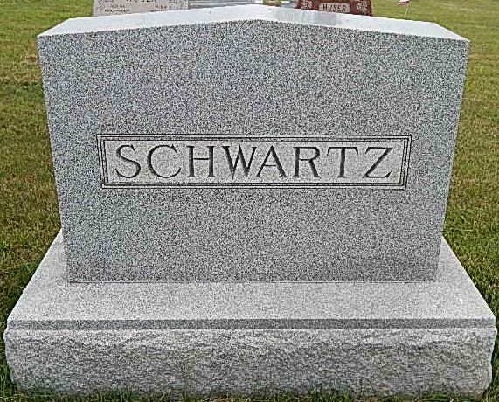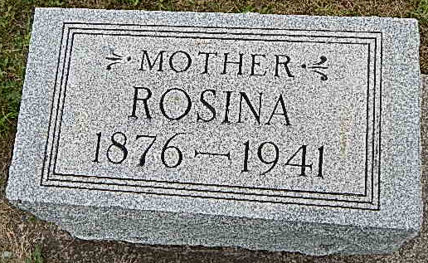
Photos by Alicia Kneuss

APOPLEXY FATAL TO MRS. ROSINA SCHWARTZ AGE 65
Funeral for Prominent Widow Is Here Friday at 2 p.m.
The people of Berne and community were stunned today when they learned of the almost unexpected death of Mrs. Rosina Burke Schwartz, 65, widow of Robert Schwartz who died at her home on West Water street last evening at 8:00 o’clock from a cerebral hemorrhage. She was ill only nine hours suffering from apoplexy Tuesday morning at 11:00 o’clock. She regained consciousness for a short time.
Always active in church, garden and household work, the decedent was born one mile south of Berne on March 2, 1876, the daughter of John and Elizabeth Hofstetter Burke. Her marriage to Robert Schwartz was an event of Nov. ?? in Berne. He, a former county commissioner, preceded 17 years ago. She lived in this community all her life moving to the present family home in 1921.
Children surviving are Miss Sylvia Schwartz, office attendant in the Dr. D. D. Jones office, Mrs. Florence Steiner of southwest of town, Elmer K., of Berne and Miss Surena Schwartz, Jefferson township teacher. Two grandchildren, Robert and Betty Steiner, survive. One brother John J. Burke of Blue Creek township and a sister, Mrs. Lawrence Beitler of Monroe survive. Three sisters, Mrs. Elizabeth Affolder, Mrs. Mary Herron and Carolina preceded.
Funeral services will be conducted at the Cross Reformed church of which she was a faithful member, Friday afternoon at 2:00 o’clock following a brief service at the home at 1:45. Rev. C. A. Schmid, pastor of the church will officiate and burial will be in the M. R. E. cemetery.
The body was removed to the home from the Yager mortuary this afternoon and friends may view the body at the home.

Adams County, Indiana Historical Museum
1941a Jan-Jun Scrapbook, Image 115
Handwritten-Wed. June 11, 1941

