Romona C. (Neuenschwander) Schwartz
April 1, 1923 – January 29, 2010

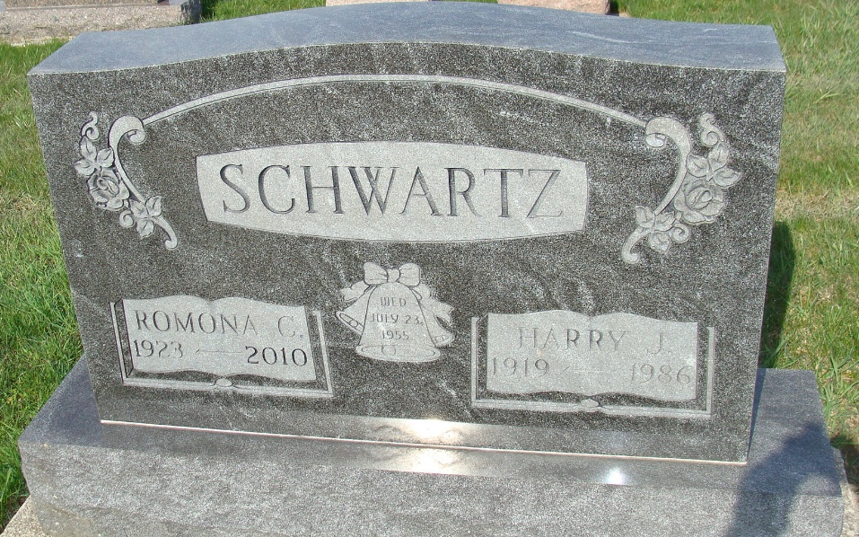
Photo by Alicia Kneuss

Romona C. “Monie” Schwartz, 86, of Berne, Indiana passed away Friday morning, January 29, 2010 at the Adams Memorial Hospital in Decatur, Indiana. Romona was born on April 1, 1923 in Adams County, Indiana the daughter of Joel and Cora (Winteregg) Neuenschwander, both deceased. She married Harry Schwartz on July 23, 1955 and he preceded her in death in 1986.
Romona was a member of the First Mennonite Church of Berne. She was previously employed by Dunbar Furniture of Berne, Gerber Furniture of Bluffton, Indiana and was co-owner of the Park Motel, retiring in 1987. She enjoyed sports and her grandchildren.
Romona is survived by a son, Doug (Linda) Schwartz of Berne; a brother, Delmar (Dessie) Neuenschwander of Berne; a brother, LeOrace (Betty) Neuenschwander of Berne; a sister, Willodyne (Harry) Luginbill of Berne; a sister, Vergene Yake of Monroe, Indiana; a sister, Floine (George) Dynes of Geneva, Indiana; a sister, Marjorie (William) Simon of Berne; and two grandchildren, Kelsey and Turner Schwartz of Berne.
Romona was preceded in death by a brother, Sherman Neuenschwander and a sister, Ellowyne Schindler.
Funeral services will be held at 10:30 a.m. Monday, February 1, 2010 at the First Mennonite Church in Berne with Gerald Tonner and Dr. Patrick Harris officiating. Interment will be in the M.R.E. Cemetery of rural Berne. Family and friends will be received from 3:00 – 8:00 p.m. Sunday, January 31, 2010 at the Yager-Kirchhofer Funeral Home in Berne and one hour prior to the funeral service at the First Mennonite Church on Monday.
Preferred memorials are to the First Mennonite Church Missions or Gideons International.
Yager-Kirchhofer Funeral Home, Adams County, Indiana

