Robert Schwartz
March 6, 1867 – April 10, 1924

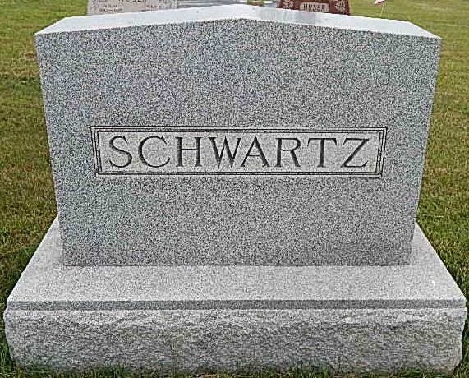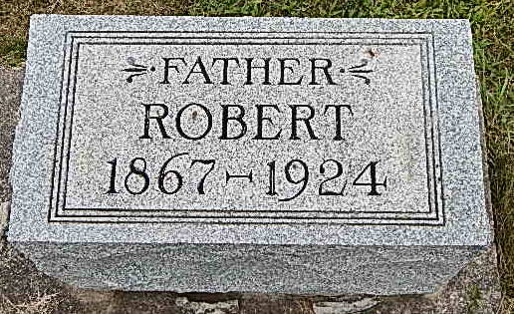
Photos by Alicia Kneuss

Indiana, U.S., Death Certificates, 1899-2017

Name Robert Schwartz
Gender Male
Race White
Marital Status Married
Age 57
Birth Date 6 Mar 1867
Birth Place Wabash Tpt. Indiana
Death Date 10 Apr 1924
Death Place Township, Adams, Indiana, USA
Death Registration Date 1924
Father Karl Schwartz
Mother Magalena Gerber
Spouse Rosa Saurer Schwartz
Informant Mrs. Robert Schwartz
Burial M.R.E. Cemetery 4/13/1924

