Minnie (Sprunger) Schwartz
December 14, 1890 – December 27, 1930

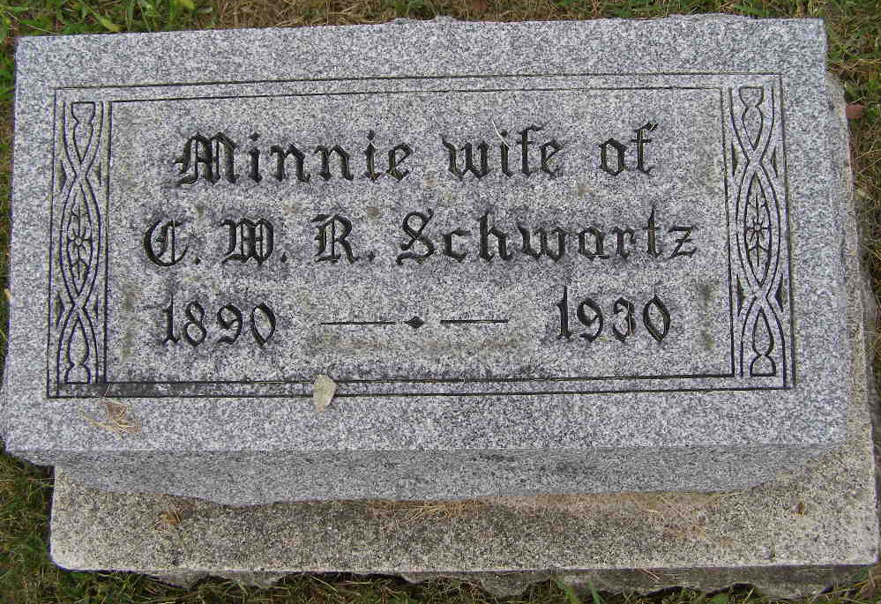
Photo by Shaunda Bedwell Opdycke

Indiana, U.S., Death Certificates, 1899-2017

Name Minnie Schwortz
[Minnie Sprunger]
Gender Female
Race White
Marital Status Married
Age 40y 0m 13d
Birth Date 14 Dec 1890
Birth Place Indiana
Death Date 27 Dec 1930
Death Place Monroe, Adams, Indiana, USA
Death Registration Date 1930
Father Philip Sprunger
Mother Anna Lehman
Spouse Christian W. R. Schwartz, informant
Burial M.R.E. Cemetery 12-30-1930

