Minnie Asenath Schwartz
February 3, 1941 – February 3, 1941

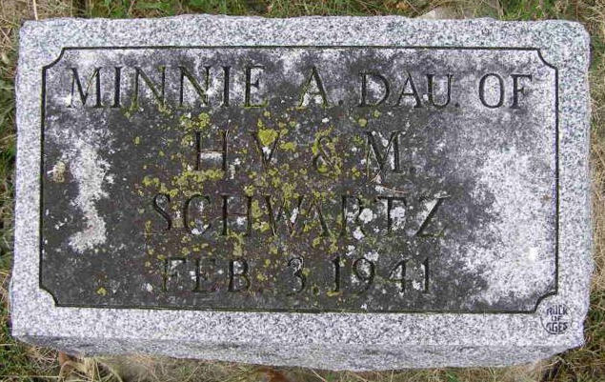
Photo by Shaunda Bedwell Opdycke

Schwartz Infant Is Buried This Morning
Burial was held in the M.R. E. cemetery at Berne this morning for Minnie Schwartz, infant daughter of Mr. and Mrs. Harold and Mary Belle Snyder-Schwartz, who died Monday afternoon shortly after birth. The parents, who reside northeast of Berne, are the only survivors.

Adams County, Indiana Historical Museum
1941a Jan-Jun Scrapbook, Image 5
Handwritten-Tues. Feb. 4, 1941

