Melvin David Schwartz
September 19, 1927 – December 19, 1937

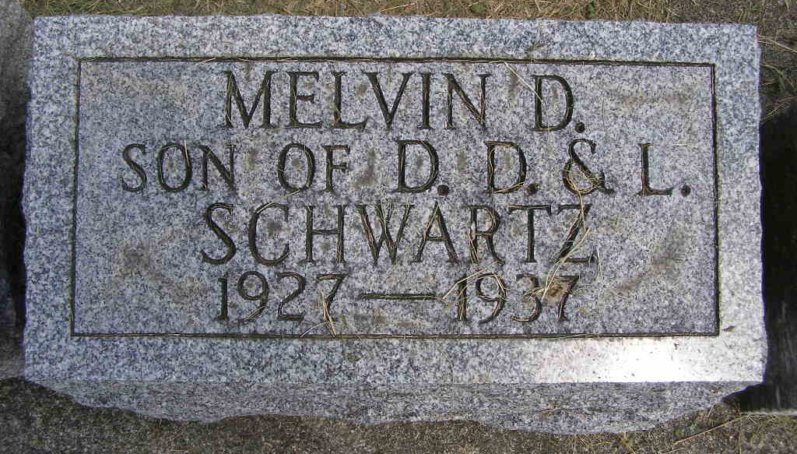
Photo by Shaunda Bedwell Opdycke

SHORT ILLNESS FATAL TO 10-YEAR-OLD LAD
Melvin David Schwartz Dies Late Sunday at County Hospital

Melvin David Schwartz, aged 10, son of Mr. and Mrs. Daniel D. Schwartz of Berne, died at 10:30 o'clock Sunday night at the Adams county Memorial hospital at Decatur, following a short illness. The lad underwent an operation Sunday afternoon for an intestinal obstruction. He rallied just slightly after the operation and little hope was held for his recovery.
The lad was born in Monroe township, on what is known as the David Schwartz farm, 4 miles northwest of Berne, Sept. 19, 1927. He was a son of Daniel D. and Leah Graber Schwartz. The family just moved to Berne last week. Mr. Schwartz formerly operated a milk route here, and is well known.
The lad became ill last Wednesday while attending the District No. 4 school, taught by Eldon Sprunger. He complained of pains in his abdomen and the boy became violently ill, suffering considerably at times. He was removed to the hospital Sunday noon.
Surviving are the parents, two brothers and one sister. One sister, Irene May, preceded in death on Jan. 7, 1929. She died following an illness almost similar to that of her brother who died yesterday. The two grandfathers David Schwartz and Peter Graber also survive.
The funeral will be held at 9:45 o'clock Wednesday forenoon at the home in the southwest part of Berne, and at 10 o'clock at the Mennonite church, Rev. C. H. Suckau officiating. Burial will be in the M.R.E. Cemetery.

Adams County (IN) Historical Museum
1937 Scrapbook
Handwritten date: Monday, December 20, 1937

