MaryBelle (Snyder) Schwartz
January 15, 1921 – March 22, 2010

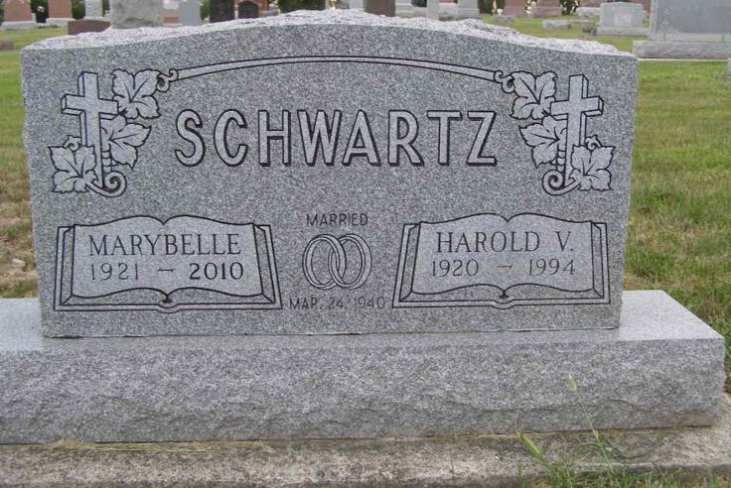
Photo by Shaunda Bedwell Opdycke

Marybelle Schwartz, 89, of Berne, passed away Monday March 22, 2010 at Swiss Village in Berne, IN. She was born in Allen County, Indiana on January 15, 1921 to the late George and Dove (Osborn) Snyder. On March 24, 1940 she married Harold Schwartz, he passed away on March 15, 1994.
Marybelle was a homemaker, and secretary for Zurcher Tire in Monroe. She was an active member of the Monroe United Methodist Church, taught Sunday School for many years, was a M.Y.F. counselor for many years, and was part of the Builders Sunday School Class and United Methodist Women.
She is survived by one son Sidney Schwartz of Monroe, IN., one brother John Snyder of Indianapolis, IN., two grandsons Doug (Anne) Schwartz , and Denny (Leann) Schwartz both of Monroe, IN., and five great grandchildren Kayla, Kelsey, Madeline, McKenna, and Conner. She is preceded in death by two sisters Daisy Harrison and Genevieve Nussbaum.
Funeral services will be held at 10:00am on Saturday March 27th at the Monroe United Methodist Church. Visitation will be on Friday March 26th from 4-8pm at the Monroe United Methodist Church fellowship hall and one hour prior to the service. The Rev Eric Stoops and Dal Fosnaugh officiating. Burial will be at M.R.E. Cemetery in Berne, Indiana.
Memorial contributions may be made to the Monroe United Methodist Church.
Haggard-Sefton & Hirschy Funeral Home, Adams County, Indiana

