Harry John Schwartz
September 6, 1919 – October 7, 1986

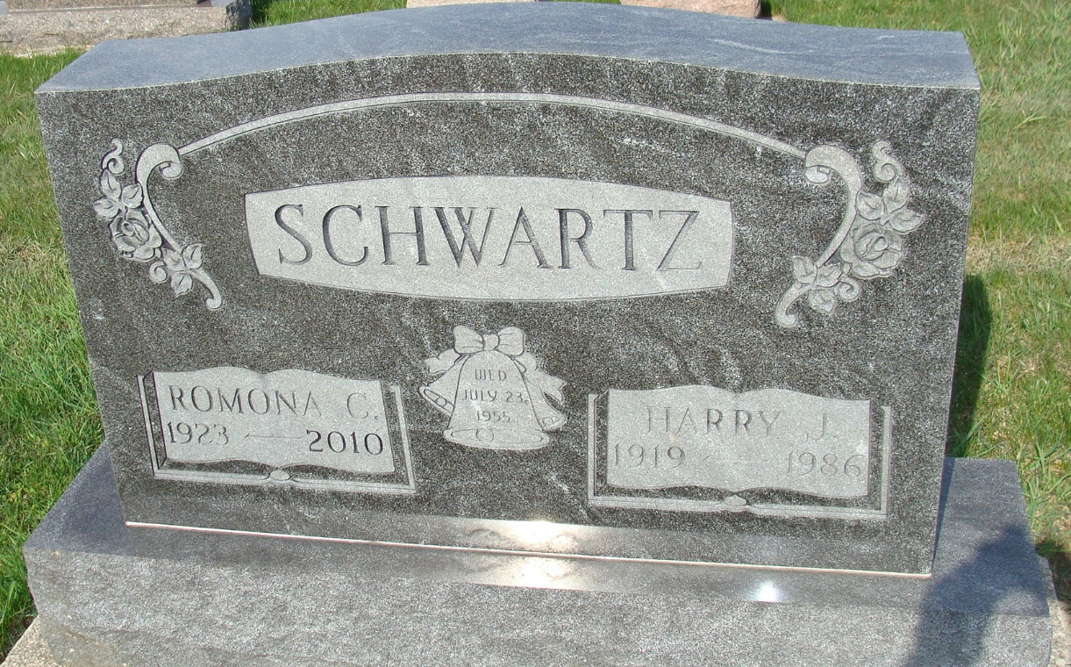
Photo by Alicia Kneuss

Indiana, U.S., Death Certificates, 1899-2017
Name Harry J Schwartz
Gender Male
Race White
Marital Status Married
Age 67
Birth Date 6 Sep 1919
Birth Place Indiana
Death Date 7 Oct 1986
Death Place Berne, Adams, Indiana, USA
Death Registration Date 1986
Father Levi Schwartz
Mother Sarah Reinhart
Spouse Romona Neuenschwander Schwartz, informant
Burial M.R.E. 10/10/1986

