Harold Victor Schwartz
June 27, 1920 – March 16, 1994

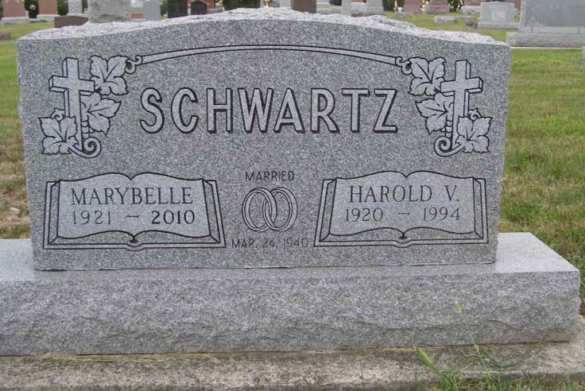
Photo by Shaunda Bedwell Opdycke

Indiana, U.S., Death Certificates, 1899-2017
Name Harold V Schwartz
Gender Male
Race White
Marital Status Married
Age 73
Birth Date 27 Jun 1920
Birth Place Adams County, Indiana
Death Date 16 Mar 1994
Death Place Monroe, Adams, Indiana, USA
Death Registration Date 1994
Father C W R Schwartz
Mother Minnie Sprunger
Spouse Mary Belle Snyder Schwartz, informant
Burial 3/19/1994 M.R.E.

