Flora Mae (Sauder) Schwartz
May 2, 1890 – May 8, 1974

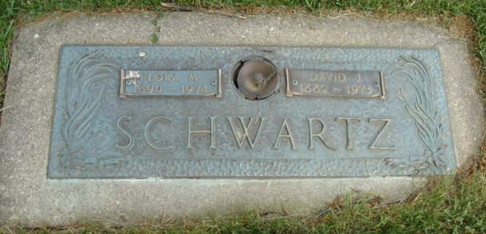
Photo by Alicia Kneuss

Flora Schwartz, 84, dies this morning

Mrs. Flora Schwartz, 84, of route 1, Berne, widow of David J. Schwartz, died at 5:30 a.m. today at her home. She was a member of the First Missionary Church.
Born in Linn Grove on May 2, 1890, she was a daughter of Joseph and Salome Stauffer-Souder, and was married on Jan. 11, 1914, to David J. Schwartz, who died March 13, 1973.
Surviving are four children, Dr. David J. Schwartz, Jr., Atlanta, Ga.; Mrs. Donald (Carmen) Aspy, Highland Park, Ill.; Mrs. M.H. (Vivian) Jack, Newark, N.J.; and Mrs. Clifford (Beth) Olt, Kettering, O.; one sister, Mrs. David (Jo) Gerig, Sun City, Ariz.; one half-sister, Ms. Gerald (Dorothy) Timmons, Berne; one half-brother, Palmer Wittwer, Columbus, O.; and six grandchildren.
Services will be held at Yager funeral home, with the funeral expected to be held Friday. Friends may call at the funeral home after 8 p.m. Thursday. Burial will be in the M.R.E. cemetery. Rev. Edwin Prosser will officiate at the services

Decatur Daily Democrat, Adams County, Indiana
Wednesday, May 8, 1974

