Ernest William Schwartz
December 19, 1915 – May 25, 2000

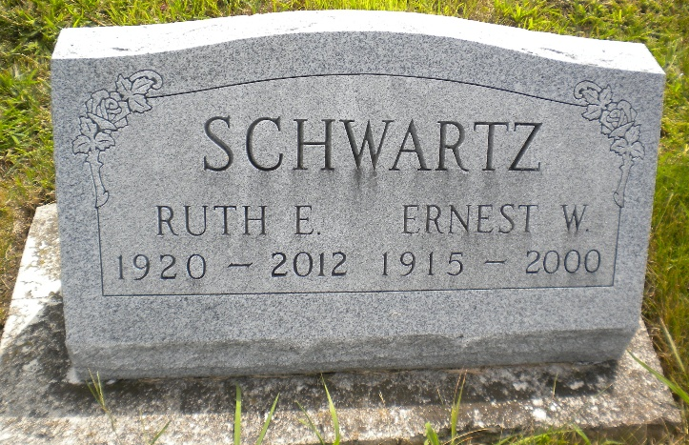
Photo by Alicia Kneuss

Indiana, U.S., Death Certificates, 1899-2017

Name Ernest W. Schwartz
Gender Male
Race White
Marital Status Married
Age 84
Birth Date 16 Dec 1915
Birth Place Adams County
Death Date 25 May 2000
Death Place Berne, Adams, Indiana, USA
Death Registration Date 2000
Father Christian W. R. Schwartz
Mother Minnie Sprunger
Spouse Ruth Nussbaum Schwartz, informant
Burial 5/28/2000 M.R.E.

