David Leroy Schwartz
August 11, 1930 – October 30, 2004

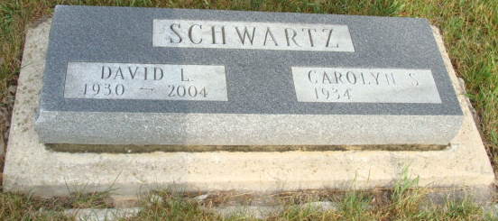
Photo by Alicia Kneuss

DAVID L. SCHWARTZ, 74, of New Haven, died Saturday, Oct. 30, 2004, at Lutheran Hospital. Born in Adams County, he was a U.S. Air Force veteran serving in the Korean conflict. David was a vice president with Mutual Security Life Insurance Co. and retired in 1997, after 27 years. He had also been a bus driver for East Allen County Schools, and a member of New Haven United Methodist Church.
He is survived by his wife, Carolyn; sons, R. Scott and wife, Linda Schwartz of Lubbock, Texas, Jeffrey N. Schwartz of New Haven; daughter, Jennifer Beckett of Paradise, Calif.; brother, Roy G. Schwartz of Decatur; sisters, Anna Lehman and Jane Velasco, both of Berne; six grandchildren;, and three great-grandchildren.
Funeral service is 10 a.m. Thursday at E. Harper & Son Funeral Home. Calling is from 2 to 4 and 6 to 8 p.m. Wednesday, and half an hour before service time, at E. Harper & Son Funeral Home, 740 Indiana Hwy., 930 E., New Haven. Memorials are to New Haven/Adams Twp. Fire Dept. or New Haven United Methodist Church. Burial in M.R.E. Cemetery, Berne.

News-Sentinel, The (Allen County, Indiana)
Tuesday, November 2, 2004

