David Joseph Schwartz
October 23, 1882 – March 13, 1973

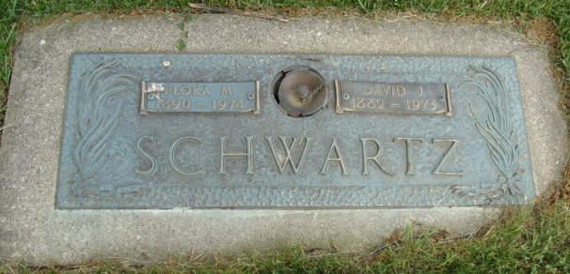
Photo by Alicia Kneuss

DAVID SCHWARTZ DIES AT HOSPITAL

David J. Schwartz, 90, of route 1, Berne, a retired farmer, died at 2:50 p.m. Tuesday at the Adams County Memorial Hospital. He had been a patient there since Saturday. He was a member of the First Missionary Church.
Born in Monroe Township on Oct, 23, 1882, he was the son of Jacob and Myra Liechty Schwartz, and was married on January 10, 1914 to Flora Sauder.
Surviving are the wife; one son, David J. Jr., of Atlanta, Ga.; three daughters, Mrs. Marion H. (Vivian) Jack, Newark, NY, Mrs. Don (Carmen) Aspy, Highland, Ill., Mrs. Clifford (Beth) Olt, Dayton, O.; two sisters, Mrs. Peter (Rachel) Mazelin, Port Treverton, Pa., Mrs. David J. (Mary) Mazelin of Decatur; one brother, Joel K. L. Schwartz, Fillmore, Calif.; six grandchildren and three great-grandchildren. Three sisters and four brothers preceded him in death.
Funeral services will be held at 10:30 a.m. Friday at the Yager Funeral Home, with Edwin Prosser officiating. Burial will be in the MRE Cemetery. Friends may call at the funeral home after 2 p.m. Thursday.

Decatur Daily Democrat, Adams County, Indiana
Wed., March 14, 1973

