William Frederick Schug
April 11, 1853 – October 31, 1918

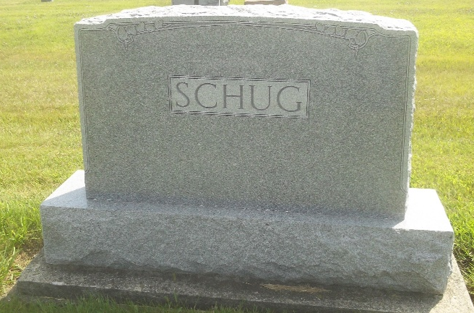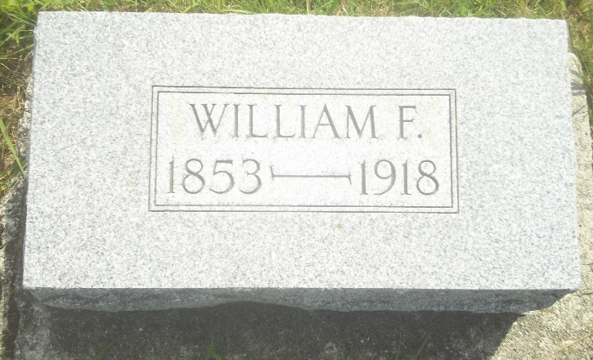
Photos by DSON1492

A SUDDEN DEATH
Came To Wm. F. Schug, Prominent Farmer of North of Berne
DIED LAST NIGHT
Was Brother of John H. Schug of This City - Funeral Sunday
A sudden death due to apoplexy came last evening at eight o'clock to William F. Schug, prominent farmer of Monroe township at his home three and a half miles north of Berne. Last February Mr. Schug had suffered a stroke of paralysis and while he had never completely regained, he had been feeling in unusually good health the past week. Last evening he had eaten a hearty supper and was in good spirits when he retired. About eight o'clock members of his family heard him groaning and hastening to his bedside found him very ill. He expired within a very few moments.
Mr. Schug was sixty-five years old. He was a very capable man and was one of the influencial farmers of his community. His first marriage was to Miss Striker, now deceased. To them were born six children, all of whom, except a daughter, Lucinda, are living. They are Ruth, wife of Hiram Witwer, of Berne; Thurman, a soldier in France; Harvey, of Poneto; Mildred and Calvin. His widow, who was Miss Clara Durr, survives, with the following children: Leona, Carl, John, Naomi and Harry.
Mr. Schug was a brother of John H. Schug, of this city; of Rudolph, Charles, Julius and Phil Schug, of Berne, and of Mrs. Dan Neuen-schwander, of Missouri.
Funeral services will be Sunday afternoon at 1:30 o'clock from the home. Burial will be in the Berne cemetery.

Decatur Daily Democrat, Adams County, Indiana
Friday, Nov. 1, 1918
**
Indiana, Death Certificates, 1899-2011
Name: William F. Schug
Gender: Male
Race: White
Age: 65
Birth Date: 11 Apr 1853
Birth Place: Ohio
Death Date: 31 Oct 1918
Death Place: Monroe, Adams, Indiana, USA
Father: Carl ?? Schug
Mother: Cathrine Rousch
Spouse: Louisa Schug; Berne, Ind.
Burial: Nov. 3, 1918; MRE Cem.

