Walter C. Schug
September 6, 1905 – December 22, 1981

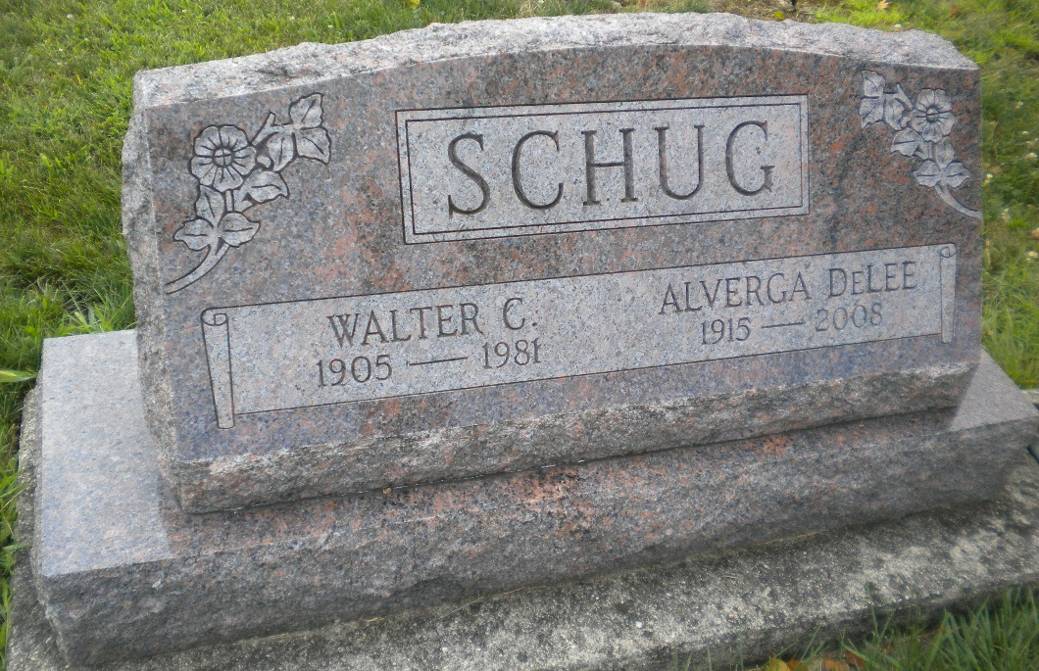
Photos by DSON1492

Indiana, U.S., Death Certificates, 1899-2017

Name Walter Schug
Gender Male
Race White
Marital Status Married
Age 76
Birth Date 6 Sep 1905
Birth Place Indiana
Death Date 22 Dec 1981
Death Place Geneva, Adams, Indiana, USA
Death Registration Date 1981
Father Julius C. Schug
Mother Emma Kelly
Spouse Delee Garlinger Schug, informant
Burial M.R.E. 12-26-1981

