Urban D. Schug
October 28, 1893 – September 2, 1958

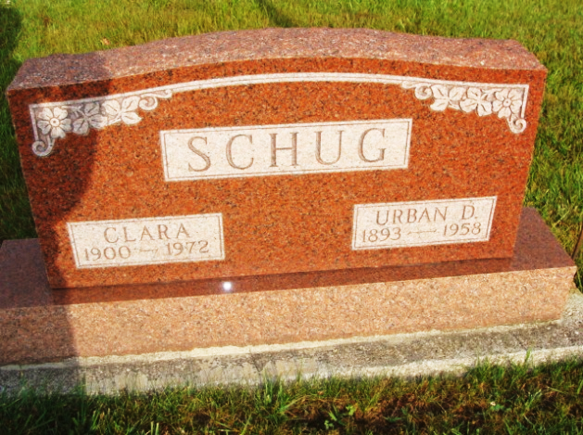
Photo by Alicia Kneuss

URBAN (REX) D. SCHUG

Hartford City – Funeral services for Urban (Rex) D. Schug, 64, former Hartford City resident, were held Thursday afternoon at the Yager Funeral Home in Berne. Burial was in a Berne Cemetery.
Mr. Schug died Tuesday at his home in Berne of a heart attack. He formerly operated a restaurant here with his brother, Oliver P. Schug, now of Ft. Wayne. Also surviving are three other brothers, Lester, Pendleton; Homer and Nelson of Berne, and a sister, Mrs. Tillman Bixler, of Berne.

Muncie Evening Press, Delaware County, Indiana
Friday, September 5, 1958
**

Indiana, U.S., Death Certificates, 1899-2017
Name Urban D. Schug
[Rex Schug]
Gender Male
Race White
Marital Status Married
Age 64
Birth Date 28 Oct 1893
Birth Place Indiana
Death Date 2 Sep 1958
Death Place Berne, Adams, Indiana, USA
Death Registration Date 1958
Father Rudolph Schug
Mother Mina Reppert
Informant Mrs. Clara Schug, wife
Burial 9/4/1958 M.R.E. Cemetery

