Thurman Schug
May 25, 1888 – August 21, 1955

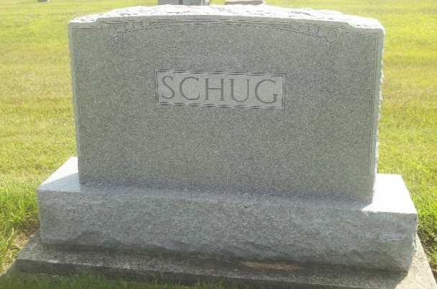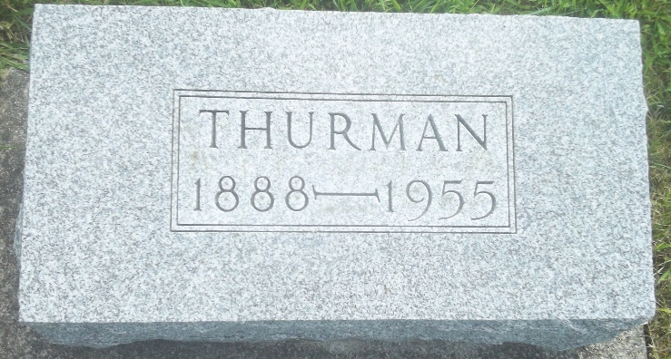
Photos by DSON1492

Indiana, U.S., Death Certificates, 1899-2017

Name Thurman Schug
Gender Male
Race White
Marital Status Never Married (Single)
Age 67
Birth Date 25 May 1888
Birth Place Indiana Monroe, Township
Death Date 21 Aug 1955
Death Place Rural, Adams, Indiana, USA
Death Registration Date 1955
Father William F Schug
Mother Alverda Shug
Burial 8/23/1935 M.R.E.

