Steven A. Schug
March 27, 1947 - January 11, 2010

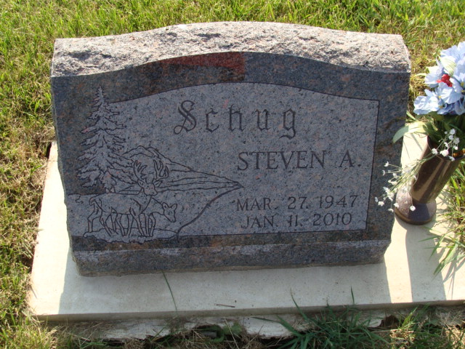
Photo by Alicia Kneuss

Steven A. Schug, 62, a resident of Findlay, Ohio for the past twenty years and a native of Berne, Indiana passed away on Monday, January 11, 2010 in Findlay, Ohio. Steven was born on March 27, 1947 in Adams County, Indiana the son of Henry and Kathryn (Teeter) Schug, both deceased. Steven was presently employed at Tower Automotive of Bluffton, Ohio and was a former Berne McIntosh Corporation employee. He was also a former member of the Berne Volunteer Fire Department.
Steven is survived by his fiancé, Linda Alberson of Berne; a sister, Susan Velez of Naples, Florida; and a sister, Scherri Krieg of Naples, Florida.
Funeral services will be held at 10:30 a.m. Friday, January 15, 2010 at the Yager Kirchhofer Funeral Home in Berne with the Rev. Anita Rediger officiating. Interment will be in the M.R.E. Cemetery of rural Berne. Family and friends will be received from 4:00 – 8:00 p.m. Thursday, January 14, 2010 at the Yager-Kirchhofer Funeral home and one hour prior to the funeral service at Yager Kirchhofer on Friday.
Preferred memorials are to WBCL Radio Station.

Yager-Kirchhofer Funeral Home, Adams County, Indiana

