Rudolph R. Schug
August 13, 1864 – September 29, 1945

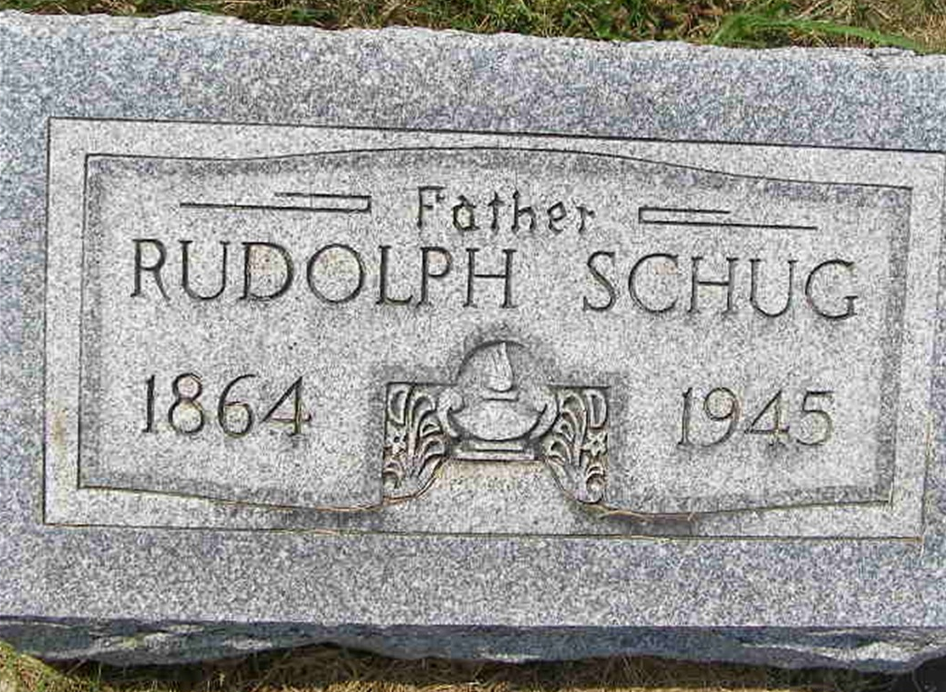
Photo by Shaunda Bedwell Opdycke

Indiana, U.S., Death Certificates, 1899-2017

Name Rudolph Schug
Gender Male
Race White
Marital Status Widowed
Age 81y 1m 17d
Birth Date 13 Aug 1864
Birth Place Vera Cruz, Indiana
Death Date 29 Sep 1945
Death Place Decatur, Adams, Indiana, USA
Death Registration Date 1945
Father Carl Schug b. Germany
Mother Catherine Rausch b. Germany
Spouse Mina Reppert Schug
Informant Emma Schug
Burial cemetery west of Berne

