Paul Melvin Schug
April 26, 1923 – March 26, 1990

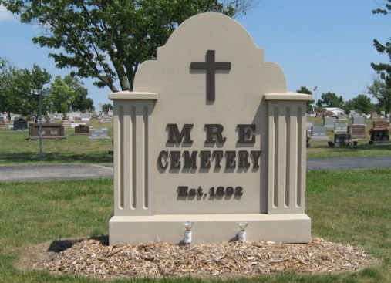
Photo by Tombstoner & Family

Paul M. Schug, 66, route 1, Monroe, died at 10:55 a.m. Monday in the extended care unit of Adams County Memorial Hospital.
He was born in Blue Creek Township on April 26, 1923 to Carl I. and Myrtle Potts Schug. His first wife, Nellie I. Armstrong, died September 14, 1988. He married Eleanor Kennel on June 3, 1989; she survives.
He retired in 1987 after a 16 1/2-year career at Dunbar Furniture in Berne and worked 17 years before that at the International Harvester plant in Fort Wayne.
Other survivors are four sons, Alan D. Schug, route 1, Monroe; Bruce E. Schug, Willshire, Ohio; Neal D. Schug, route 8, Decatur; and Darain G. Schug, Monroe; three stepsons: Steven Hult, Berne; Terry Hult, Soth Lake Tahoe, California; and Eric Hult, Redding, California; two sisters, Mrs. Jim (Clara Lou) Teeple, Monroe, and Mrs. Raymond (Lois) Christman, route 1, Monroe; one foster brother, Leonard Schug, route 1, Monroe; and eight grandchildren.
Funeral services are at 10:30 a.m. Thursday in Yager-Kirchhofer Funeral Home, Berne, Rev. Ersel Potts officiating. Burial will be in MRE Cemetery, Berne. Visiting hours are 2-9 p.m. Wednesday and 8-10:30 a.m. Thursday.
Preferred memorials are to Salem United Methodist church.

Decatur Daily Democrat, Adams County, Indiana
Tuesday, 27 March 1990

