Otto F. Schug
May 2, 1937 – March 9, 2007

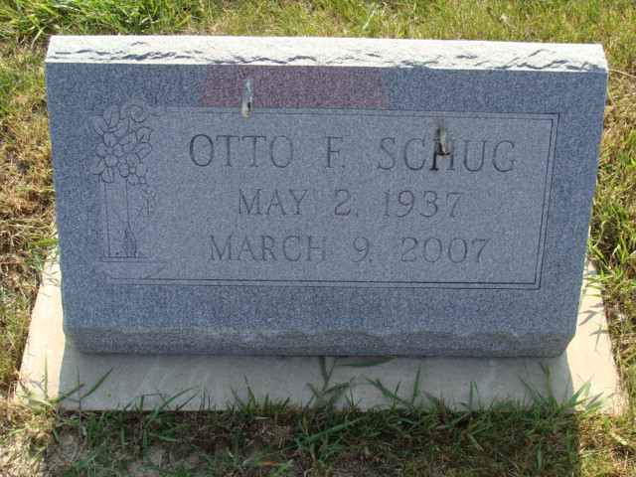
Photo by Alicia Kneuss

Indiana, U.S., Death Certificates, 1899-2017

Name Otto F Schug
Gender Male
Race White
Marital Status Divorced
Age 69
Birth Date 2 May 1937
Birth Place Berne, Indiana
Death Date 9 Mar 2007
Death Place Columbus, Bartholomew, Indiana, USA
Death Registration Date 2007
Father Everett Schug
Mother Charolette Scronski
Informant Chip Schug, son
Disposition 3/10/2007 Anatomical Education Program
**

Adams County (IN) Public Library News Search - obit abstracts

Publication: Decatur Daily Democrat; Date: 13 JUL 2007, p. 3A
Title: Schug, Otto F.; Subjects: Obituaries -- S -- 2000-
Abstract: Age: 69
Died: March 9, 2007 - Columbus
Children: A son and a daughter
He was a native of Berne, Indiana.

