Otto F. Schug
February 15, 1885 – July 8, 1907

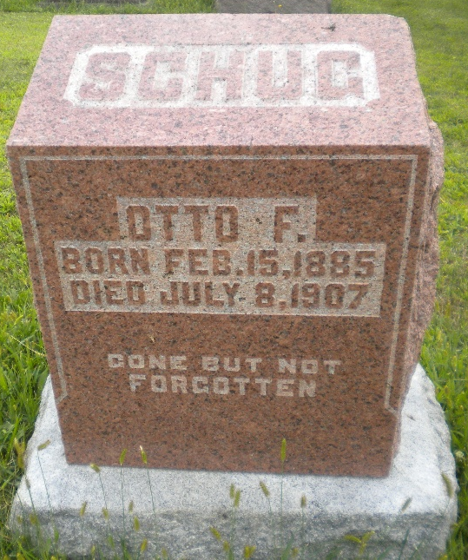
Photo by DSON1492

Otto F Schug from Witten, Beans, Giauque, Neuenschwander Family Tree

Birth 15 Feb 1885 Berne, Adams, Indiana, USA
Residence 1900 Berne, Adams, Indiana, USA
Death 8 Jul 1907 Fessenden, Wells, North Dakota, USA
Father Phillip Schug (1861-1934)
Mother Anna Almira Striker (1864-1919)
4710 People 3 Records 6 Sources

Death
8 Jul 1907 • Fessenden, Wells, North Dakota, United States
According to the Decatur Daily Democrat, 12 Jul 1907, Otto was working for a farmer near Fessenden, ND, driving a team of horses to town after a load of brick, when he was struck by a fast train at a crossing about 3 miles from Fessenden. He died instantly.

