Nellie Inez (Armstrong) Schug
August 1, 1928 – September 14, 1988

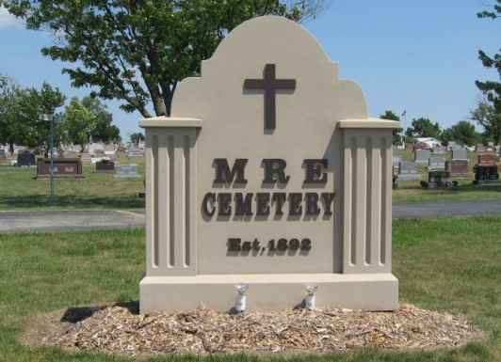
Photo by Tombstoner & Family

Indiana, U.S., Death Certificates, 1899-2017

Name Nellie Inez Schug
[Nellie Inez Armstrong]
Gender Female
Race White
Marital Status Married
Age 60
Birth Date 1 Aug 1928
Birth Place Farmers, Rowan County, Kentucky, USA
Death Date 14 Sep 1988
Death Place Monroe, Allen, Indiana, USA
[Fort Wayne, Allen, Indiana, USA]
Death Registration Date 1988
Father Everett Armstrong
Mother Ada Olive Choat
Spouse Paul Schug, informant
Burial 9-17-1988 MRE Cemetery

