Naomi Christina Schug
February 1, 1910 – March 27, 1966

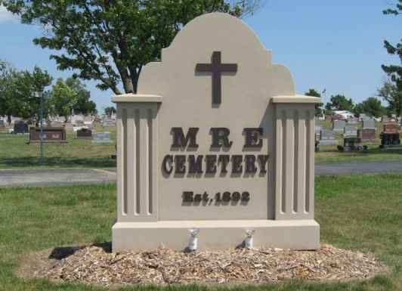
Photo by Tombstoner & Family

Naomi Schug Of This City Dies Late Sunday
Stroke Fatal to Dunbar Office Employee, 56
Miss Naomi Christina Schug, 56, 417 Center street, died at 7:00 p.m. Sunday at the Adams County Memorial hospital. Death was attributed to a massive cerebral hemorrhage which followed an illness of two weeks of the flu. She suffered the stroke Sunday afternoon and was admitted to the hospital about 4:00 p.m. Sunday.
Miss Schug was prominently known and was employed with the Dunbar firm for 33 years. Miss Schug was a lifelong resident of this community and resided with her sister, Leona at the Center street address.
She was born in Monroe township February 1, 1910, a daughter of William F. and Clara Louise Durr Schug. She had resided in Berne for many years.
Surviving are three brothers, Carl Schug, Monroe R.R. 1; John W. Schug, Miami Florida and Harry W. Schug, Newsport Richie, Florida; a sister, Leona F. Schug, Berne; a half-sister, Mildred Schug of Warren and a half-brother, Herman Schug, Berne; and ten nieces and nephews. A sister, two half-sisters and three half-brothers preceded in death.
Miss Schug was a member of the Cross United Church of Christ.
The body is at the Yager Funeral home where friends may call after 1:00 p.m. Tuesday. Services will be held at the funeral home at10:00 a.m. Wednesday, Rev. Robert Hegnauer, pastor of the Cross church, officiating. Burial will be in the M.R.E. cemetery.
Date of death 28 March 1966; Date of burial 30 March 1966
Berne (IN) Library Heritage Room
MRE Obit Book 1966-1972

