Nannie (Burkholder) Schug
December 20, 1858 – February 14, 1921

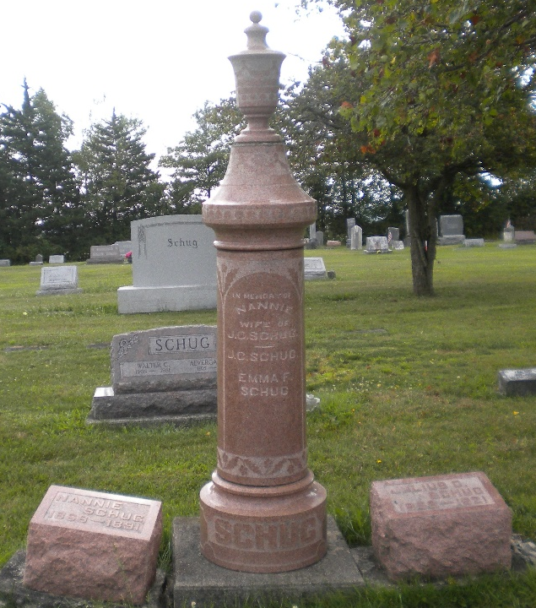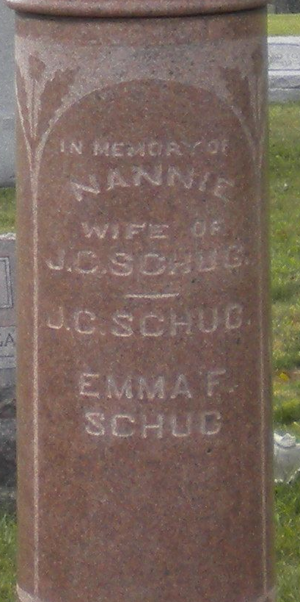
Photos by DSON1492

Indiana, U.S., Marriage Index, 1800-1941

Name Nannie Burkholder
Marriage Date 19 Jun 1890
Marriage Place Carroll, Indiana, USA
Spouse Name Julius B Schug
**

Nancy J. Burkholder from tree Stoner-Grierson Family Tree

Birth 1869 Carroll, Indiana, USA
Residence 1880 Carroll, Indiana, USA
Marriage 19 Jun 1890 Carroll, Indiana, USA
Death 21 Jul 1891 Berne, Adams, Indiana, USA
Father Christian Burkholder (1829-1900)
Mother Susannah "Susan" Stoner (1843-1912)
Spouse Julius Caesar Schug (1858-1921)
26904 People 1 Record 3 Sources

