Mina (Reppert) Schug
November 26, 1867 – June 14, 1936

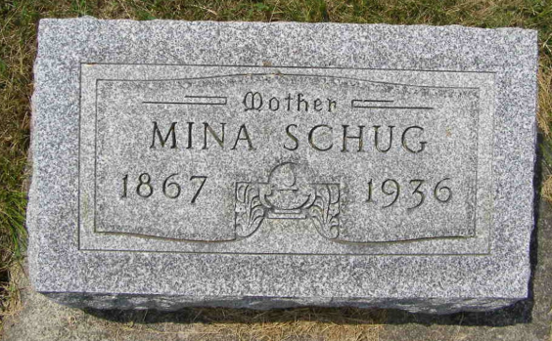
Photo by Shaunda Bedwell Opdycke

MRS. RUDOLPH SCHUG EXPIRES HERE SUNDAY
Well-Known Local Woman Dies Suddenly From Apoplexy
FUNERAL IS WEDNESDAY P.M.

The people of Berne and community were shocked today to hear of the sudden and untimely death of Mrs. Mina Schug, aged 68, wife of Rudolph Schug of this place, which occurred at 8:45 o'clock Sunday evening at her home at 906 West Main Street. Death was caused by cerebral hemorrhage, or apoplexy. Mrs. Schug had been in usual health Sunday morning, and attended church services Sunday forenoon. About 11 o'clock, while she was preparing dinner, she complained of having pains in her neck. She also complained of not feeling well otherwise and collapsed while sitting on a chair. Mrs. Schug remained conscious until 4 o'clock Sunday afternoon, when she became unconscious and remained in a coma until death.
Mrs. Schug was well and favorably known, her husband for many years being president and cashier of the Peoples State Bank, and otherwise active in business here. Mrs. Schug, whose maiden name was Mina Reppert, was born in Preble township, near Preble, Nov. 26, 1867, a daughter of Fred and Louisa Sellmeyer Reppert. At the time of her death she was 68 years, 6 months and 18 days old.
She spent her entire life in Adams (cut off)...and the couple has lived in Berne since 1905. Surviving are the husband and the following children: Mrs. Austin (Stella) Gilliom, Berne; Oliver Schug, Ft. Wayne; Urban D. Schug, Detroit; Luster R. Schug, Pendleton; Homer Schug and Nelson Schug, Berne, and Emma C. Schug, at home. Violet Esther Reppert, who made her home with the Schug family since she was 16 months old, also survives. She was taken into the home when her mother died. Mrs. Schug was an aunt of Miss Reppert.
The following brothers and sisters survive: William Reppert, near Monroe; Mrs. Charles Walters, Vera Cruz; Fred Reppert, Decatur; Mrs. John Fulk, Bluffton, and Mrs. Jacob Pfeifer, Bluffton rural route. One son, Harry Walter, died at the age of 14 months. Six grandchildren survive.
Mrs. Schug's father died at the age of 88, 7 years ago, and her mother died last February, at the age of 87. Mrs. Schug was confirmed at the St. John's Reformed church at Vera Cruz when Rev. Peter Vitz was pastor. She later had her membership transferred to the Cross Reformed church here, and had been (cut off)

Adams County (IN) Historical Museum
1936 Scrapbook, image 51
Handwritten: Monday, June 15, 1936

