Lucinda Catherine Schug
April 18, 1884 – November 23, 1898

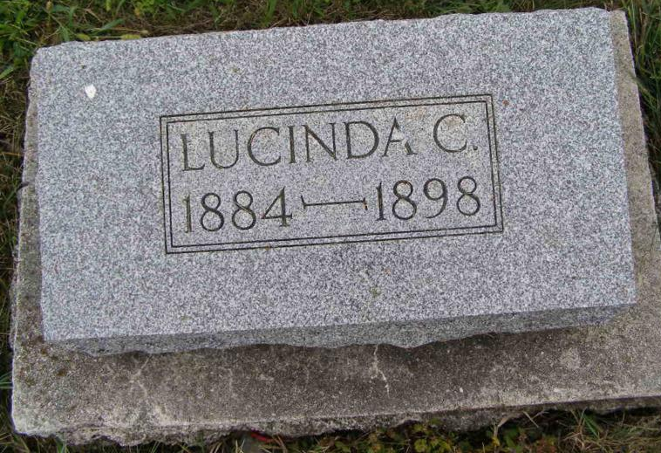
Photos by Shaunda Bedwell Opdycke

Catharine Lucinda Schug was born at the home of her parents, Mr. and Mrs. W. F. Schug in Monroe Township, Adams County, Indiana on April 18, 1884. She early on developed a taste for literature and music, a taste which increased each year. One day, at the age of 14, in the latter part of April as she was jumping rope with a few of her playmates she fell on her face, knocking out a couple of teeth and received cranial injuries. But for a long time it was not thought she was dangerously hurt. She went about her work and play in her usual way, but complained now and then of severe headache.
In the middle of June she began to take sick spells. Her reading and singing, which was her life, became interrupted by dizziness. So that she could keep it up only a little while at a time. These spells occurred more often and with greater intensity through July and August. Until the 29th of September the unfortunate young daughter became bedfast. Her condition now grew critical in spite of all the medical attention she received. She suffered excruciating pain in her head and at last the world and all her pleasant surroundings of parents and little brothers and sisters become lost to her in darkness-she lost her sight in both eyes, and in that pitiful condition, subjected to intense suffering she held out six weeks until she stepped out into a world that is free from sorrow and free from pain.
When her father began to fear that his daughter was sick unto death, he asked her if she was prepared to die, whereupon she diligently sought peace with God until she found the saving faith in Jesus. This was a few weeks before her death and during this time she often expressed great joy to depart and meet her Savior, and had visions of angels and chariots and of her younger sister who is in heaven. She made preparations for her burial, gave descriptions for her casket and garment and picked out her pall-bears and then waited for her lost hour which came on Wednesday, November 23rd, having brought her age to 14 years, 7 months, and 5 days. Her last words were, "I'm so rich in Jesus, He suffered more for me."
Catharine Lucinda was preceded in death by her mother and a sister and now leaves to mourn their loss a father, step-mother, three brothers and three sisters. Her funeral was held by Rev. B. Ruf on Friday, November 25th, at the Sharon church and her remains were laid to rest beside her mothers in Backstow cemetery.
The Parents extended their sincere thanks to all their neighbors and friends who so kindly administered during the days that sadness visited their family.

Berne Witness, Adams County, Indiana
December 1898

