Lois Franchion Schug
April 19, 1919 – March 27, 1920

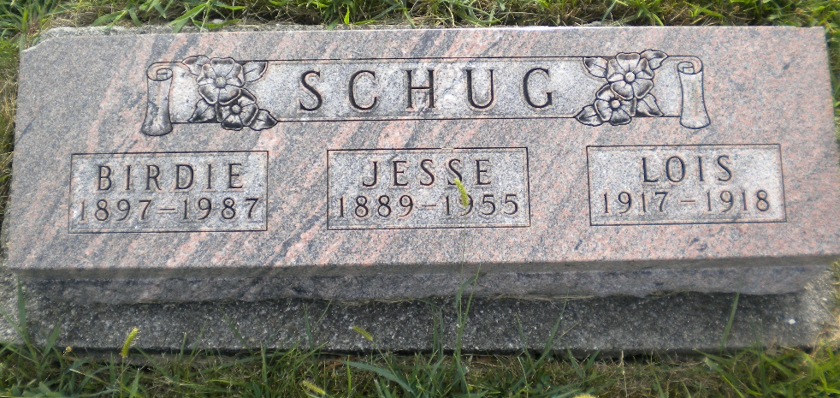
Photo by DSON1492

Michigan, U.S., Death Records, 1867-1952

Name Lois Fauchion Schug
Gender Female
Race Caucasian (White)
Marital Status Single
Death Age 11m 8d
Birth Date 19 Apr 1919
Birth Place Wyandotte, Michigan
Death Date 27 Mar 1920
Death Place Wyandotte, Wayne, Michigan, USA
Father Jesse Schug, informant
Mother Birdie Hoffman
Burial Berne, Indiana 3/29/1920
File Number 2701

