Lily Mae Schug
August 14, 1889 – August 14, 1889

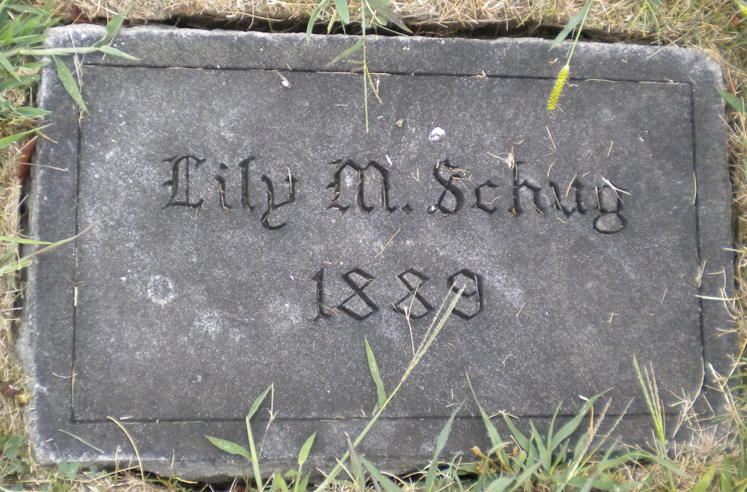
Photos by DSON1492

Lily Mae Schug from tree Dunlap Family Tree
Birth 14 Aug 1889 Berne, Adams, Indiana, USA
Death 14 Aug 1889 Berne, Adams, Indiana, USA
Father Charles C Schug (1856-1926)
Mother Catharina A. Stauffer (1854-1890)
38626 People 1 Record 3 Sources

