Leona F. Schug
September 1, 1897 – April 15, 1977

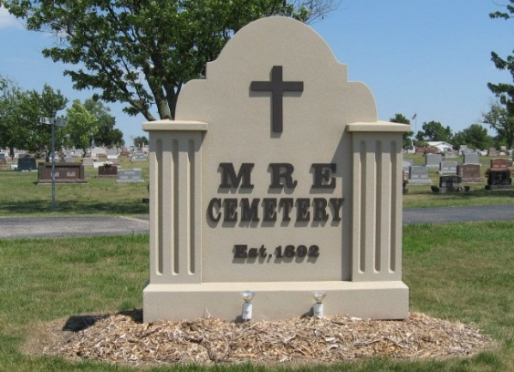
Photos by Tombstoner & Family

Services were held at 2 p.m. Sunday at the Yager Funeral Home for Leona F. Schug, 79, who died in the nursing care unit of Swiss Village at 1:55 p.m. Friday. Death was attributed to heart failure. She had been in declining health the past year. Rev. M. C. Macklin of Monroe officiated at the funeral and burial was in M.R.E. Cemetery.
Miss Schug had been in Swiss Village since Oct. 4, 1976. She was retired from the Dunbar Furniture office where she was employed when she became blind. She was blind for 42 years, then regained her eyesight nine years ago. Miss Schug resided at 417 Center Street before entering Swiss Village.
She was born in Monroe Township Sept. 1, 1897, a daughter of William and Clara Durr Schug. The only survivor is a brother of Harry O. Schug, Panama City, Florida. Preceding in death were six brothers, Carl, Herman, John, Harve, Thurman and Clavin Schug and three sisters, Naomi, Mildred and Mrs. Hiram (Ruth) Wittwer.
Berne (IN) Library Heritage Room
1973-1984 MRE Obit Book, image #149

