Lenora Ernestine (Yoss) Schug
March 26, 1905 – August 26, 1957

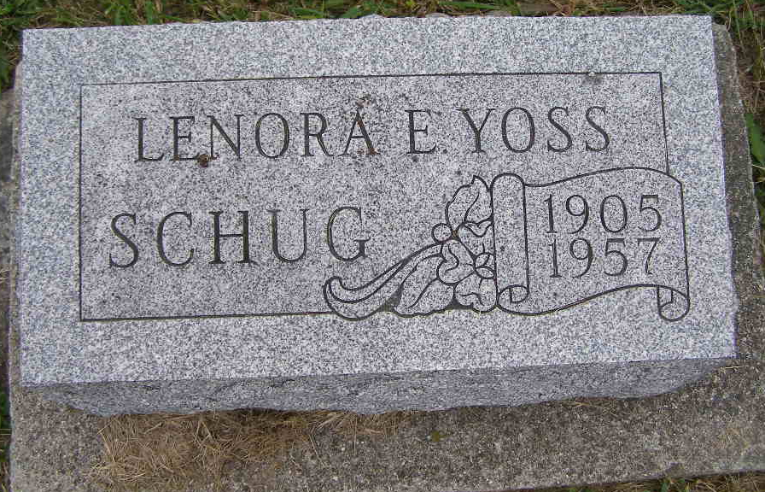
Photo by DSON1492

Funeral Here Thursday For Lenora Schug
Local Woman, 52, Dies Late Monday After Long Illness

Funeral services will be held at 10:00 a.m. Thursday at the Berne Church of the Nazarene for Mrs. Lenora E. Schug, 52, of 577 Behring Street who died at 7:30 p.m. Monday at the Adams County Memorial Hospital. Rev. Carl Greek, pastor of the church and Rev. Ray Tucker of Fort Wayne, former local pastor, will officiate. Burial will be in the M.R.E. Cemetery.
Mrs. Schug's death was attributed to carcinoma. She was in the hospital the past seven weeks and bedfast for three months. She submitted to surgery a few years ago, recovered and returned to work but six months ago she began to fail again. Mrs. Schug was employed in the sewing department of the Berne Furniture Company.
A lifelong resident of this community, Mrs. Schug was born March 26, 1905, the daughter of Fred and Leah Mary Lehman Yoss.
Surviving are two daughters, Mrs. Fred (Shirley) Sprunger, Marion and Mrs. Merlin (Alice) Habegger of Berne; two sons, Jack C. Schug, Huntington and Paul L. Schug, Indianapolis; eight grandchildren and the following brothers and sisters; Anatole Yoss, New Castle; Paul Yoss, Geneva R.R.; Felix Yoss, Mrs. Mary Bill, Mrs. Harold Blake, and Mrs. Blondine Frankhart, all of Fort Wayne; Mrs. Carl Faulkner, London, Kentucky; Mrs. Irvin Sprunger, near Geneva and Mrs. Fred Fennig, Berne.
A brother, Garfield Yoss and a sister, Margaret, preceded in death.
Friends may call at the Yager Funeral Home until 9 a.m. Thursday when the body will be taken to the local Church of the Nazarene.

Adams County Indiana Historical Museum
1955 Mar-April 1958 Scrapbook, Image 115
Handwritten-Wed. Aug. 28, 1957
*

Indiana, U.S., Death Certificates, 1899-2017

Name Mrs Lenora E. Schug
[Mrs Lenora E. Yose]
Gender Female
Race White
Marital Status Divorced
Age 52
Birth Date 26 Mar 1905
Birth Place Indiana
Death Date 26 Aug 1957
Death Place Decatur, Adams, Indiana, USA
Death Registration Date 1957
Father Fred Yoss
Mother Leah Mary Lehman
Informant Mrs. Merlin Habegger, daughter
Burial Aug. 29, 1957 M.R.E. Cemetery

