Lelia (Farris) Schug
August 7, 1900 – September 17, 1968

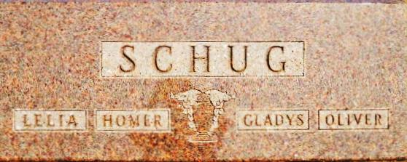
Photo by Alicia Kneuss

Funeral Here Tuesday for Widely Known 68-Year-Old Woman

Mrs. Lelia Farris Schug, 68, 109 East Main Street, died at Parkview Memorial Hospital in Fort Wayne at 6:25 pm Saturday, on her 31st wedding anniversary. She had been hospitalized for three weeks. The first two weeks of her hospitalization were in the constant care ward. Death is attributed to diabetic acidosis. She had been confined to a wheel chair for ten years following amputation of both of her legs.
She was known as a woman with unusual determination and courage and operated an apron shop at her home on Main Street until her final illness. She made many of the aprons, had a good business and became widely known through her work. She was stricken with a light heart attack a few weeks ago, appeared to recover and was returned to her home here where she resumed her apron business. Then her fatal illness struck.
A few years ago Mrs. Schug gained much favorable publicity with her “Lelia Bags.” This was an article designed for hospital patients in which they could keep their personal belongings.
A native of Portland, Mrs. Schug had been a resident of Berne for 31 years. She was born August 7, 1900, a daughter of Lewis and Leona Frakes Farris. She was married Sept. 14, 1937 to Homer E. (Hap) Schug. The husband survives, also a step-daughter, Mrs. Thearl (Ellen) Stults, Decatur. Mrs. Schug was a member of the Cross United Church of Christ.
Services will be held at 1:30 pm Tuesday at the Yager Funeral Home where friends may call. Rev. Robert L. Hegnauer will officiate and burial will be in the MRE Cemetery.

Date of Death: 1968 Date of Burial: Saturday, September 17, 1968 Burial: Lot 29, Sect 2, 4th Add

Berne (IN) Library Heritage Room
MRE Obits 1967 – 1969, Image 162

