Katie A. Schug
June 9, 1890 – June 9, 1890

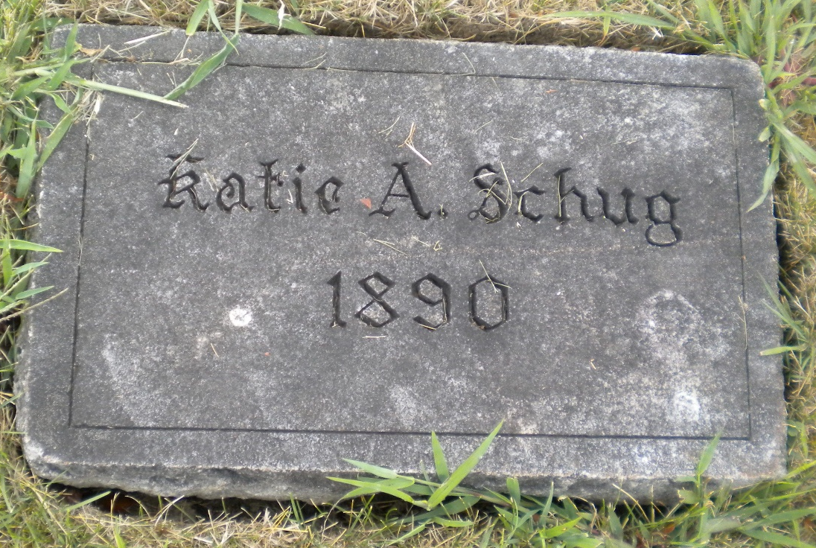
Photo by DSON1492

Katie A. Schug from tree 2 SA DNA June Ashley Family Tree

Birth 9 Jun 1890 Berne, Adams, Indiana, USA
Death 9 Jun 1890 Berne, Adams, Indiana, USA
Father Charles C. Schug (1856-1926)
Mother Catherine Stauffer (1854-1890)
225620 People 0 Records 1 Source

