Katherine (Rausch) Schug
April 23, 1838 – December 22, 1902

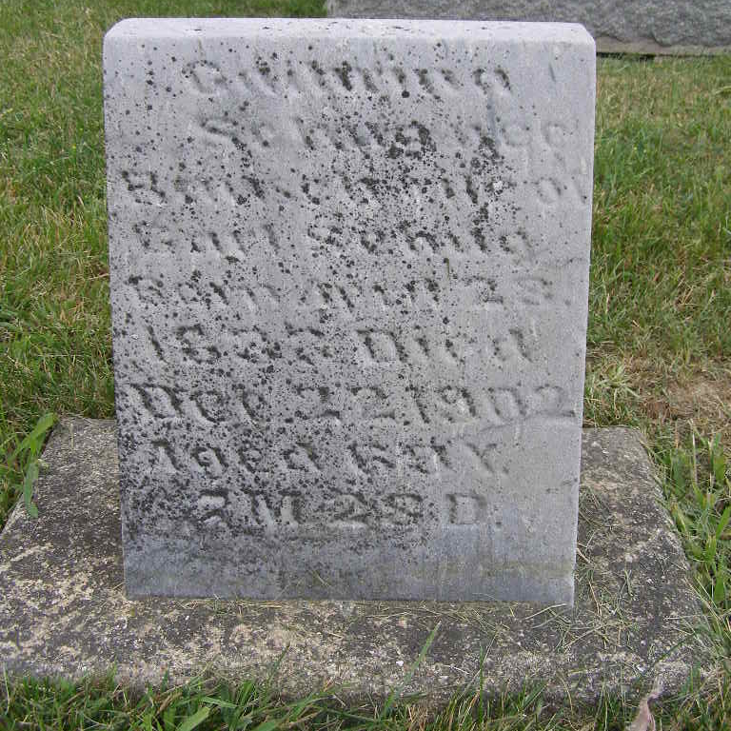
Photos by Shaunda Bedwell Opdycke

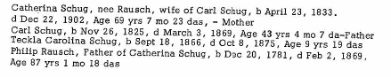
Cemetery Records of Adams County, Vol II, Mary Penrose Wayne, DAR Chapter, Fort Wayne, Ind.
**
Ohio, U.S., County Marriage Records, 1774-1993
Name Catharine Rausch
Gender Female
Marriage Date 2 May 1850
Marriage Place Tuscarawas, Ohio, USA
Spouse Charles Chughe
Film Number 000317307

