Julius C. Schug
December 20, 1858 – February 14, 1921

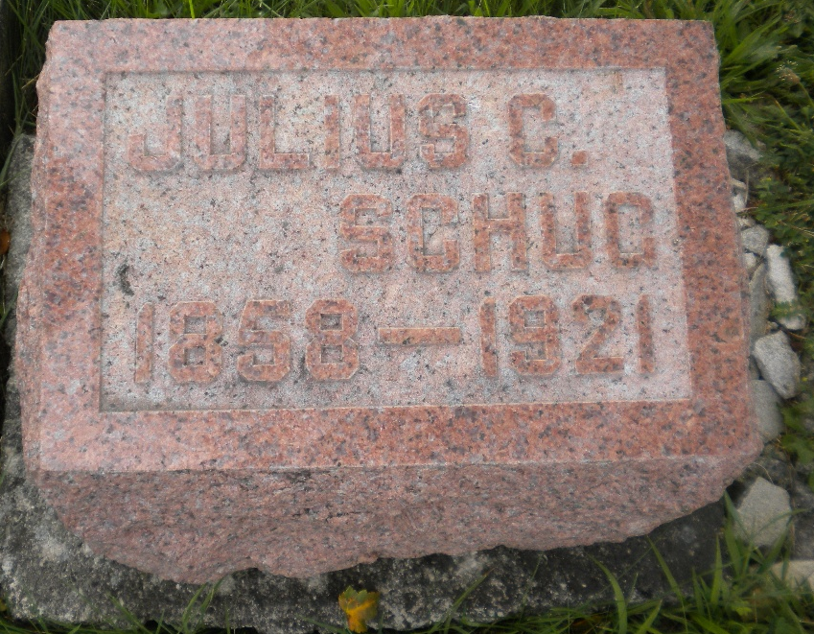
Photo by DSON1492

Indiana, U.S., Death Certificates, 1899-2017

Name Julius C Schug
Gender Male
Race White
Age 62y 1m 24d
Marital Status Married
Birth Date 20 Dec 1858
Birth Place Ohio
Death Date 14 Feb 1921
Death Place Berne, Adams, Indiana, USA
Death Registration Date 1921
Father Carl Schug b. Germany
Mother Catherine Roush b. Germany
Spouse Emma Schug
Informant Mrs. J. C. Schug
Burial MRE 2-17-1921

